THE UNITED KINGDOM OF GREAT BRITAIN AND NORTHERN IRELAND
1. Where is the United Kingdom situated?
2. What is the area of the United Kingdom?
3. What countries does it consist of?
4. What is the highest mountain on the British Isles?
5. What is the longest river?
6. What is the highest mountain in Wales?
7. What is the northern part of Scotland called?
8. What is the population of the United Kingdom?
9. How many people live in London?
10. What industry is developed in South Wales?
11. What kind of state is the United Kingdom?
12. What houses does the British parliament consist of?
13. What are the main political parties?
14. Who chooses the Cabinet of Ministers?
15. What is the flag of the United Kingdom called?

THE UNITED STATES OF AMERICA
1. Where is the USA situated?
2. What area has the USA?
3. What mountains are there in the country?
4. What is situated between the Cordilleras and the Appalachian mountains?
5. What are the main rivers?
6. What kind of climate is there in the USA?
7. What is the population of the USA?
8. How many states are there in the USA?
9. What kind of state is the USA?
10. Who is the head of the state?
11. What is the capital of the USA?
12. What are the main parties?
13. What is the financial & business centre of the country?
14. When is Thanksgiving Day celebrated?
15. When is Independence Day celebrated?

CANADA
1. What is the capital of Canada?
2. What is the area of Canada?
3. Where is Canada situated?
4. What is Canada rich in?
5. What is the population of Canada?
6. What are the most important cities?
7. What are Canada’s largest ports?
8. What are the largest lakes in Canada?
9. What mountains are there in Canada?
10. What are the longest rivers?
11. What is the largest island in the north of Canada?
12. What kind of state is Canada?
13. How many provinces and territories does it consist of?
14. What houses does the Federal Parliament consist of?
15. What are Canada’s main agricultural products?

THE COMMONWEALTH OF AUSTRALIA
1. What is the official name of Australia?
2. What territories are there in the Commonwealth of Australia?
3. What area has Australia?
4. What is the capital of Australia?
5. In what hemisphere is Australia situated?
6. What is the population of Australia?
7. What are the biggest cities in Australia?
8. What is the main occupation in Australia?
9. What agricultural product is Australia famous for?
10. What are the longest rivers?
11. What mountains are there in Australia?
12. What does Australia consist of?
13. What houses does the Federal Parliament consist of ?
14. Who is formally the head of the state?
15. Who represents the Queen of England?

NEW ZEALAND
1. Where is New Zealand situated?
2. What islands does it consist of?
3. On which island are there many lakes?
4. What sea washes the western coast of New Zealand?
5. What is the highest mountainous range?
6. What is the national emblem of New Zealand?
7. What is the capital?
8. What are the main cities?
9. What is the nickname of New Zealand?
10. Which city resembles Edinburgh?
11. What is the population of New Zealand?
12. Who are the Maoris?
13. What are they famous for?
14. What houses does the Parliament consist of?
15. Who represents the Queen of England?

KEYS
THE UNITED KINGDOM OF GREAT BRITAIN AND NORTHERN IRELAND
1. On the British Isles.
2. Over 244,000 square kilometres.
3. England, Scotland, Wales and Northern Ireland.
4. Ben Nevis.
5. The Severn.
6. Snowdon.
7. Highlands.
8. Over 57 million people.
9. More than 9 million.
10. Coal-mining.
11. Constitutional monarchy.
12. The House of Lords and the House of Commons.
13. The Conservative and Labour Parties.
14. The Prime Minister.
15. The Union Jack.
THE UNITED STATES OF AMERICA
1. In the central part of the North American Continent.
2. Over nine million square kilometres.
3. The Cordillera, the Rocky Mountains, the Appalachian.
4. The prairie and the Mississippi valley.
5. The Mississippi, the Colorado, the Columbia.
6. Several different climatic regions.
7. More than 236 million people.
8. Fifty states.
9. A federal republic.
10. The president.
11. Washington, D.C.
12. The Democratic and Republican Parties.
13. New York.
14. The fourth Thursday in November.
15. The fourth of July.
CANADA
1. Ottawa.
2. Nearly 10 million square kilometres.
3. In the northern part of the North American continent.
4. Metal ores, oil and gas.
5. Over 24 million people.
6. Montreal, Toronto, Edmonton, Hamilton, Winnipeg, Quebec.
7. Vancouver, Montreal, Halifax.
8. The Great Lakes Superior, Huron, Erie and Ontario, Great Bear Lake, Great Slave Lake and Lake Winnipeg.
9. The Rocky Mountains.
10. The Mackenzie, Yukon, St. Lawrence River.
11. Baffin Island.
12. A federal state and a member of the Commonwealth.
13. Ten provinces and two territories.
14. The Senate and the House of Commons.
15. Wheat, meat, some kinds of fruit and dairy products.
THE COMMONWEALTH OF AUSTRALIA
1. The Commonwealth of Australia.
2. The Continent of Australia, the island of Tasmania and a number of smaller islands.
3. About 8 million square kilometres.
4. Canberra.
5. The South hemisphere.
6. About 15 million people.
7. Sydney, Melbourne, Adelaide, Perth, Brisbane.
8. Agriculture.
9. Sheep.
10. The Murray and the Darling.
11. The Australian Alps, the Blue Mountains.
12. Six states and two territories.
13. The Senate and the House of Representatives.
14. The Queen of England.
15. The governor-general.
NEW ZEALAND
1. South-east of Australia.
2. North Island, South Island and Stewart Island, and also many small islands.
3. North Island.
4. The Tasman sea.
5. The Southern Alps.
6. Kiwi.
7. Wellington.
8. Auckland, Christchurch, Dunedin.
9. The Britain of the Pacific.
10. Dunedin.
11. Over 3 million people.
12. The aboriginal Polynesian inhabitants of New Zealand.
13. Folk songs, music, dances and wood work.
14. The House of Representatives.
15. The governor-general

Цели: Познакомить учащихся с творчеством популярной попгруппы “Битлз”. Активизировать познавательную деятельность учащихся, расширяя их кругозор. Развить интерес учащихся к культурному наследию Великобритании. Создать творческую атмосферу в гостиной.
Подготовка: презентация творческой деятельности группы “Битлз” с использованием видеофрагментов на компьютере, разучивание песен, отработка слов ведущих; “вымышленная” группа “Битлз”.
Оборудование:
- мультимедийная установка,
- компьютер,
- магнитофон,
- видео, набор музыкальных записей,
- тексты песен,
- портреты членов группы в подводной лодке.
Ход мероприятия
Пока собираются зрители и участники, звучат песни в исполнении “Битлз”.
Pupil 1: Good afternoon! Welcome to our submarine. Do you know who thought this name?
Answer: The Beatles.
Pupil 1: Right you are. Today we have a trip in our yellow submarine. Now let’s sing the song “Yellow submarine”.
Все участники и гости поют песню, слова раздаются.
Yellow submarine
In the town where I was born lived a man who sailed the sea,
And he told us of his life in the land of submarines.
So we sailed up to the sun till we found the sea of green.
And we lived beneath the waves in our yellow submarine.
We all live in a yellow submarine,...
And our friends are all on board,
Many more of them live next door,
And the band begins to play.
We all live in a yellow submarine,...
And we live a life of ease,
Every one of us has all we need.
Sky of blue and sea of green in our yellow submarine.
We all live in a yellow submarine,...
Pupil 2: Liverpool is the hometown of the Beatles.
Pupil 3: They were all born in Liverpool.
Pupil 4: The citizens of Liverpool are proud of their famous countrymen.
Показ видеофрагмента о городе Ливерпуле.
Pupil 2:
The Beatles Story Museum was founded by Ringo Starr in April 1984. In the Museum Halls you see the Beatles’ films, books and magazines. You can also buy different souvenirs, stamps, plates and cups with the Beatles’ portraits, or records and cassettes with their songs. You can listen to their songs here as well. I suggest you singing one of the most popular their songs “Girl”.
Girl
Is there anybody going to listen to my story
All about the Girl who came to stay?
She's the kind of Girl you want so much it makes you sorry,
Still you don't regret a single day
Ah, Girl, Girl,...
When I think of all the times I tried so hard to leave her
She will turn to me and start to cry
And she promises the earth to me and I believe her,
After all this time I don't know why.
Ah, Girl, Girl,...
She's the kind of Girl who puts you down when friends are there,
You feel a fool. When you say she's looking good,
she acts as if it's understood, She's cool, ooh, ooh, ooh,
Girl, Girl,...
Was she told when she was young that pain would lead to pleasure?
Did she understand it when they said
That a man must break his back to earn his day of leisure?
Will she still believe it when he's dead?
Ah, Girl, Girl,.,
На экране портрет Джона; рассказ сопровождается показом видеофильма.
Pupil 3:
There were four people in this group. John Lennon is considered to be the organizer and the leader of the ensemble. He was born on the 9th of October 1940 in Liverpool. John's father, Alfred (or Fred) worked as a waiter on merchant ships. John's mother's name was Julia Stanley; she was kind and cheerful. John lived with his mother only for 18 months. His father was thought to have died at sea, so Julia re-married. This is why John was brought up by his aunt Mary, Stanley's elder sister. John called her Mimi.
Mimi was kind and clever, but very strict and sometimes sharp. She loved little John very much. her greatest wish was to give John good education. He entered an elementary school at the age of five.
John enjoyed painting. His favourite book was Alice in Wonderland. Later, he was fond of reading books by Robert Louis Stevenson and Edgar Allan Poe, or books about artists. After finishing the elementary school, John attended the Quarry Bank Grammar School for Boys. However, the teachers didn't like him because John wouldn't follow the strict rules. John wasn't a good student at his school. His mother Julia encouraged her son to pursue musical hobbies, teaching him to play the harmonica. Julia later bought a guitar for her son and John spent a lot of hours playing different melodies.
One day he had the idea to organize a band. The group was formed and called themselves The Quarry Men. The boys began playing at home and school parties, birthday parties and street holidays. John became acquainted with Paul McCartney at one of the holidays in 1956. John Lennon once said that the story of the Beatles had begun on that day when he had met Paul McCartney.
На экране портрет Пола, рассказ сопровождается показом видеофильма.
Pupil4:
James Paul McCartney was born on June 18, 1942. His mother Mary was a nurse in one of the hospitals. She was a very reserved, patient and diplomatic woman. His father James McCartney was 9 years older than his mother. He was an employer. Paul had a younger brother Michael. They were good friends. People called them twins. As a boy, Paul was patient and kind; everybody called him a diplomat.
Paul performed well at the Liverpool Institute, doing best at Latin, Greek and English Spelling. He took an active part in extracurricular activities. At school Paul found out that he was left-handed – he couldn’t write with his right hand.
The McCartney family loved music. His father often played the piano at home. Paul was 13 years old when his mother died. The boys and the father felt a terrible loss. Paul was keen on football, but music didn’t play an important part in his childhood. However, he learned to compose songs on his piano very quickly. Paul asked his father to buy him a guitar. He had to rearrange the strings on his guitar because he played with his left hand. Paul was fond of rock’n’roll and Elvis Presley. His brother Mike remembers, “When Paul took up the guitar, he forgot everything. He didn’t want to waste time even for dinner. He played everywhere even in the bathroom and in the toilet …”
Pupil 5:
Paul McCartney and John Lennon met for the first time at the church square in Vulton. Neither of them knew that they would be best friends.
One of Paul’s first ballads “And I Love Her” is devoted to his girlfriend Jane Asher. It is charming, amazing and very intimate. Let’s sing it all together.
And I Love Her
I give her all my love
That's all I do
And if you saw my love, you'd love her too.
I love her.
She gives me everything
And tenderly
The Kiss my lover brings, she brings to me
And I love her.
A love like ours could never die
As long as I have you near me
Bright are the stars that shine
Dark is the sky
I know this love of mine will never die
And I love her.
Pupil 6:
McCartney joined Lennon's group The Quarry Men. The two began to compose songs together, and it was those songs that drew the people's attention to them. Their first professional concerts were in Hamburg, Germany and it was there that they perfected their sound. They had to play night after night and after two years, they had become an exciting band to watch. Lennon was always the rebel and made an impressive figure on stage. When they moved back to Liverpool, they began to play at the Cavern Club, where all the new bands were playing. They found a manager, Brian Epstein, who gave them a new “clean” image. He tried to get them a record company deal, but no one would take them on at first. Finally, the small label Parlophone released “Love Me Do”, a Lennon \ & McCartney composition. Will you sing it, please.
Love Me Do
Love, love me do.
You know I love you,
I'll always be true,
So please, love me do.
Whoa, love me do.
Love, love me do.
You know I love you,
I'll always be true,
So please, love me do.
Whoa, love me do.
Someone to love,
Somebody new.
Someone to love,
Someone like you.
Love, love me do.
You know I love you,
I'll always be true,
So please, love me do.
Whoa, love me do.
Love, love me do.
You know I love you,
I'll always be true,
So please, love me do.
Whoa, love me do.
Yeah, love me do.
Whoa, oh, love me do.
На экране портрет Джорджа; рассказ сопровождается показом видеофильма.
Pupil 7:
George Harrison was born on February 12, 1943, in a big and friendly family. There were four children in the family, of which George was the youngest. His mother, Louisa, was merry and very kind. She worked as a shop-assistant. His father, Gerald Harrison, was a tall thin man. He was a bus driver.
George was a very obedient child. He helped old people and took care of animals. Unfortunately, he was often ill. During his childhood he wasn't interested in music, but he was fond of various shows. He was a very good student in school. It took him little time to do his homework due to the fact that he had a good memory. Later on he learned to sew and altered his school trousers to fashionable tight ones. He went in for track-and-field athletics, played football, swam well and liked riding bikes. When George studied at the Institute he became interested in skiffle. His idol was Lonny Donegan. Louisa bought a guitar for her son. George taught himself to play the guitar with a book. He couldn't play well at first, and his fingers got bloody. With the help of his mother he was able to learn to play the guitar. One day on his way to the Institute George met Paul McCartney on the bus. They became friends and had the same interests. Harrison played the guitar better than Paul and was invited to the group, becoming the leading guitarist.
На экране портрет Ринго, рассказ сопровождается показом видеофильма.
Pupil 8:
Ringo Starr was born on July 7, 1940. His father, Richard Henry Parkin Starki, worked as a baker. His wife, Elsie Gleeve, was a waitress in a bar.
Elsie worked hard, which is why little Richard had to stay alone or at their neighbour’s. Richard was very sociable as a result. He was a very weak boy and often missed classes at school. He couldn’t read even at the age of 8, though Elsie tried her best to help her son.
He was invited to join the group in summer 1962. He was paid 25 pounds a week.
Pupil 1:
Thus, the group was formed. The Beatles changed pop music forever. From their first single “Love Me Do” in 1962, people heard something different from the usual pop of that time. Their songs seemed more musical than others and more exciting than the kind of thing most artists were recording then. The Beatles also looked nicer than anyone else. More and more people began to listen to pop music than before. A hysteria that the newspapers called “Beatlemania” swept through Britain and America. In 1964 the film “A Hard Day’s Night” was made. In this film we can see John, Paul, George and Ringo and listen to their songs.
The song “Yesterday” is the best song in the album “Help!”, which was released in 1965. It is the most popular Beatles song. “Yesterday” is a romantic ballad. What is the origin of this song? Every morning Paul sat at the piano and played his own music. The melody of “Yesterday” appeared one morning while Paul was cooking breakfast. That's why first he named the song “Scrambled eggs”. But he couldn’t think of words. Nice sad music didn’t agree with simple words. The words came after several days and they were charming. Let’s try to sing it all together.
Yesterday
Yesterday,
All my troubles seemed so far away,
Now it looks as though they're here to stay
Oh, I believe in yesterday.
Suddenly
I'm not half the man I used to be,
There's a shadow hanging over me,
Oh, yesterday came suddenly.
Why she had to go
I don't know she wouldn't say
I said something wrong
Now I long for yesterday.
Yesterday,
Love was such an easy game to play,
Now I need a place to hide away
Oh, I believe in yesterday.
Why she had to go
I don't know she wouldn't say
I said something wrong,
Now I long for yesterday.
Учащиеся-ведущие-журналисты берут интервью у членов группы в аэропорту (“вымышленная” группа).
Pupil 2: The four Beatles were often interviewed by a lot of journalists and reporters. They liked to answer numerous questions. They were witty, merry and played jokes. Here's one of the interviews with the Beatles at the airport.
Reporter (R): Could you tell me how long you will perform together?
John: About 5 years.
R.: Have you got wigs on?
John: If that's so they are the most natural wigs that have ever been made. They are even with dandruff.
R.: What kind of guitar have you got, Paul?
Paul: This is Hoffman's bass guitar.
R.: Is it expensive?
Paul: 56 guineas I could have bought a more expensive one but I'm a miser.
R.: Ringo, why have you got so many rings on your fingers?
Ringo: Because I can't have them all in my nose.
R.: What would you like to say to American youth?
Ringo: I'd like them to buy more “The Beatles” records.
R.: What do you think of Beethoven?
Ringo: I like him very much, especially his poems.
R.: Could you tell me, George, why you haven’t got a tie on?
George: And why haven’t you got a hat on?
R.: Have you ever cut your hair?
George: I did it yesterday.
R.: What would you like to bring home from America?
George: Rockefeller Centre.
R.: What can you say about the song “Yellow Submarine”?
Ringo: “Yellow Submarine” is an interesting song. Reality and fantasy are mixed in it. It is a witty and happy song with sad implication and a dynamic arrangement. We can hear the sounds of the sea, seagulls, the band, sounds of lapping water and the captain’s commands. Every 5 year old boy dreams about the adventures of a seaman.
Our submarine is waiting for us. Let’s sing this song again.
Исполняется песня “Yellow Submarine”
Pupil 3: Our trip has finished. Thank you for your coming. We hope you’ve had a wonderful time with legendary English group “The Beatles” and of course you’ve learned a lot of new information about them.
Звучит музыка группы “Битлз”.

"Рождественский марафон"

Сценарий праздника.
1. Формирование команд.
Три команды по 8 человек. В командах ученики с 6-го по 9-е классы. Каждый участник имеет значок с номером своей команды (1, 2, 3). Каждая команда выбирает капитана, который всегда должен находиться впереди команды.
2. Начало игры. Команды выстраиваются на “старте”.
Учитель: Сегодня мы проводим необычный марафон, он посвящен Рождеству. Вы будите путешествовать по “станциям”. Указатели станций помещены на дверях классов. Рождество – это семейный праздник. Каждая команда – это своеобразная семья. Во время игры вы должны будите показать сплоченность.
Правила игры:
- Команды передвигаются от станции к станции только взявшись за руки. Разрыв цепи наказывается штрафом, т.е., штрафными баллами.
- На станциях команда выполняет задание, которое оценивается по пятибалльной системе.
- Время на станциях ограничено:
“Рождественская мастерская – 10 минут”;
“Символы Рождества” – 10 минут;
“Праздничные открытки” – 10 минут;
“Кроссворд” – 10 минут;
“Переводчики” – 15 минут;
“Концертный зал” – от 30 до 45 минут.
- Неспортивное или слишком шумное поведение штрафуется.
- Выигрывает та команда, которая первая пройдет свой маршрут и при этом наберет большее количество баллов.
Название станций написано на английском языке. На каждой станции – жюри: учитель и ученики 10–11-х классов. Каждой команде вручается маршрутный лист. Команда, взявшись за руки, бежит по своему маршруту. Между станциями стоят учащиеся – наблюдатели, которые следят за порядком.
Учитель: получите маршрутные листы.
Маршрутные листы.
#1.
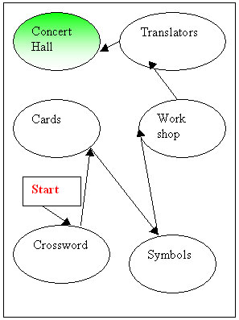

#2
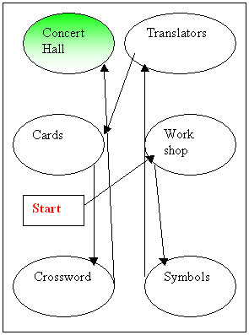

#3
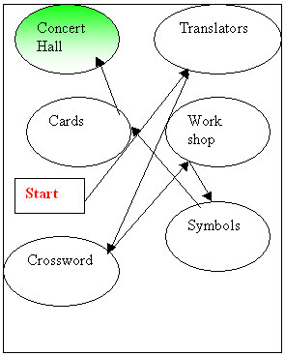

3. Игра. Станции.
Станция “Переводчики”.
На этой станции учащиеся получают тексты на английском языке и письменно переводят на русский язык. Жюри выставляет баллы в маршрутном листе.
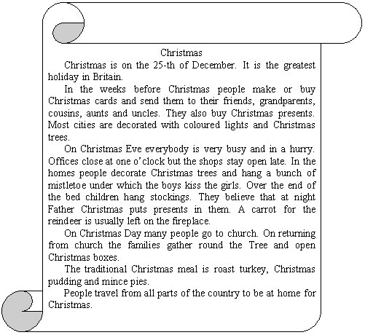
Станция “Рождественская мастерская”.
На этой станции участники получают инструкцию на английском языке и изготовляют поделку.
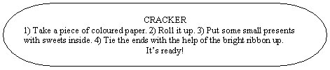
Станция “Символы Рождества”.
Участники находят слова, относящиеся к Рождеству, и украшают ими елочку.
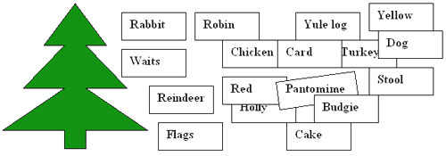
Станция “Праздничные открытки”.
Команды подписывать как можно больше открыток. (Открытки рисовали учащиеся всех классов, лучшие были отобраны для игры)
Станция “Кроссворд”.
Учащиеся разгадывают кроссворд. Жюри выставляет баллы.
c | h | r | i | s | t | m | a | s | e | v | e | e
c | h | r | i | s | t | m | a | s | b | o | x | x
c | h | r | r | s | t | a | a | h | z | y | o | k
s | o | c | i | m | n | i | b | o | r | a | m | b
g | g | b | c | s | o | a | l | l | r | a | i | s
n | s | s | a | n | t | a | c | l | a | u | s | e
i | i | s | r | r | t | m | c | y | a | t | t | l
k | k | o | o | s | t | i | a | w | d | f | l | d
c | f | z | l | y | r | m | k | s | o | p | e | n
o | f | x | y | n | e | c | a | r | d | s | t | a
t | t | n | e | s | e | r | p | q | g | a | o | s
s | t | a | h | q | g | o | l | e | l | u | y | x
Hats, Christmas, Christmas Box, candles, stockings, Yule log, robin, Christmas Eve, Santa Claus, holly, waits, carols, cards, tree
Станция “Концертный зал”. Конечная станция.
Зал заранее украшен: гирлянды, рождественский венок на двери, елочка, под елочкой подарки, горят свечи.
На конечной станции собираются все участники и зрители праздника. Участники показывают концерт (песни, стихи, сценки, фокусы и т.д.).
4. Окончание игры. Подведение итогов

