

SONG 3

# Closer by The Chainsmokers

**Learning Focus**: Present Continuous. Simple Past. Comparative.

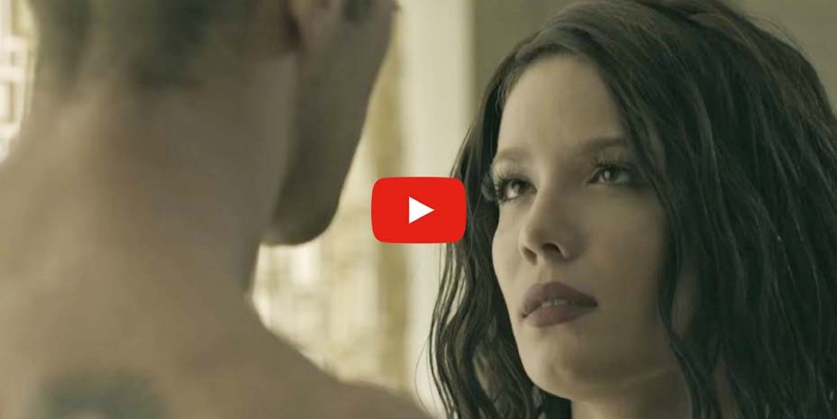

**About The Chainsmokers**

The Chainsmokers are an American DJ/production duo consisting of Andrew Taggart and Alex Pall. The song Closer became their first number-one single on the chart. In this song, they had the collaboration of Halsey, who is an American singer. The song topped the charts in major music markets.



*21*

# Activities

## – Complete with the words you listen:

Hey, I was doing just fine before I you

I drink too much and that's an but I'm okay Hey, you tell your friends it was nice to them But I hope I never them again

I know it your heart

Moved to the city in a down car And four years, no calls

Now you're pretty in a hotel bar And I can't stop

No, I can't stop

## – Now put the sentences in the correct order:

( ) From your roommate back in Boulder ( ) That I know you can't afford

( ) Pull the sheets right off the corner ( ) Bite that tattoo on your shoulder

( ) Of the mattress that you stole ( ) We ain't ever getting older

( ) So baby pull me closer in the backseat of your Rover

We ain't ever getting older We ain't ever getting older



*22*

## - Complete with the words you listen:

You as good as the day I met you

I just why I left you, I was insane Stay and play that Blink-182 song

That we to death in Tuscon, okay

I know it breaks your heart

Moved to the city in a broke down car And four years, no call

Now I'm looking pretty in a hotel bar And I can't stop

No, I can't stop

## - Put the sentences in the correct order:

( ) From your roommate back in Boulder ( ) Pull the sheets right off the corner

( ) Bite that tattoo on your shoulder

( ) So baby pull me closer in the backseat of your Rover ( ) We ain't ever getting older

( ) That I know you can't afford

( ) Of the mattress that you stole

We ain't ever getting older We ain't ever getting older

So baby pull me closer in the of your Rover That I you can't afford

Bite that tattoo on your

Pull the sheets right off the corner Of the that you stole

From your back in Boulder We ain't ever getting older

We ain't ever getting older (we ain't ever getting older) We ain't ever getting older (we ain't ever getting older) We ain't ever getting older (we ain't ever getting older) We ain't ever getting older

No we ain't ever getting older

## – Change the sentences below into the past tense. Check the lyric for some help:

1. You steal the mattress from your roommate.
2. I am insane.
3. I move to another city.
4. They play that Blink-182 song.
5. I drink too much.



*24*

## – What are they doing? Relate the sentences with images:

1. She’s drawing D) She’s singing
2. He’s reading E) He’s drinking
3. She’s eating F) She’s painting

( ) 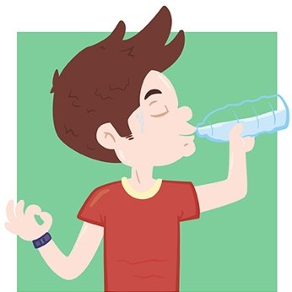 ( ) 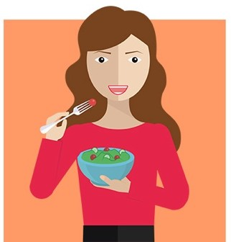 ( ) 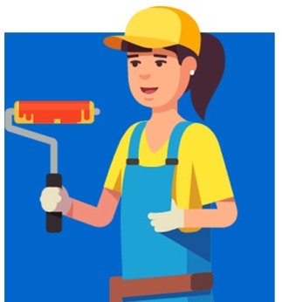

( )  ( )  ( ) 



*25*

## – Read the hints and complete the Crossword Puzzle with the verbs in the Present Continuous:

|  |  |  |  |
| --- | --- | --- | --- |
| ACROSS: |  | | |
| 4. Do | 6. Bite | 7. See | 8. Close |
| DOWN: |  |  |  |
| 1. Play | 2. Study | 3. Speak | 5. Listen 9. Let 10. Stop |

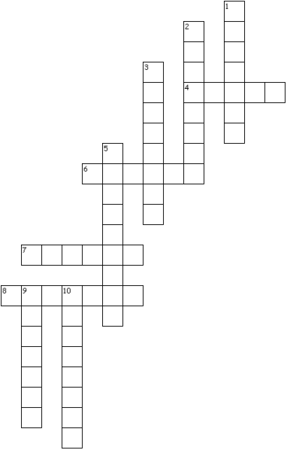

1. **– Closer, older, there are some comparative words in this song. For short nouns, we just add -er. But for bigger nouns we need to use more, as more beautiful, more dangerous. Complete the sentences using the correct comparative:**
2. This tower is (tall) than the other one.
3. Josh is (old) than my brother.
4. This river is (long) than Amazon River.
5. I think Drake is (handsome) than Derick.
6. My son is
7. It’s a fact. Hippos are

(curious) than your daughter.

(dangerous) than lions.

1. England is (small) than the United States.



*26*

1. In my opinion, German is (difficult) than English.
2. Jane is (young) than Jackie.
3. Is Joshua (intelligent) than Don?



*27*

SONG 4

# Hello by Adele

 **Learning Focus**: Adverbs of Frequency.



**About Adele**

Adele is an English singer and songwriter. She has won many awards in the past few years and has become one of the greatest artists of all time. A lot of her famous song are about her ex-boyfriend. She wrote them after they broke up. Hello is one of these songs.



*28*

# Activities

## – Listen to the song and complete the lyrics:

Hello, it's me

I was if after all these years You'd like to meet, to go over They say that time's supposed to heal ya But I ain't done much

Hello, can you hear me?

I'm in california about who we used to be When we were younger and free

I've how it felt before the world fell at our feet

There's such a difference between

And million miles

Hello the other side

I must've called a thousand times tell you I'm sorry, for everything that I've done

But when I you never seem to be home

Hello from the outside

At least I can that I've tried to tell you I'm sorry, for breaking your heart

But it don't matter, it clearly doesn't you apart anymore

Hello, how are you?

It's so typical of me to talk about I'm sorry, I hope that you're Did you ever make it out of that town

Where ever happened?



*29*

It's no

That the both of us are running out of time

So hello from the other side

I must've called a times to tell you I'm sorry, for everything that I've done

But I call you never seem to be home

Hello from the

At least I can say that I've tried to tell you I'm sorry, for breaking your heart

But it don't matter, it doesn't tear you apart anymore

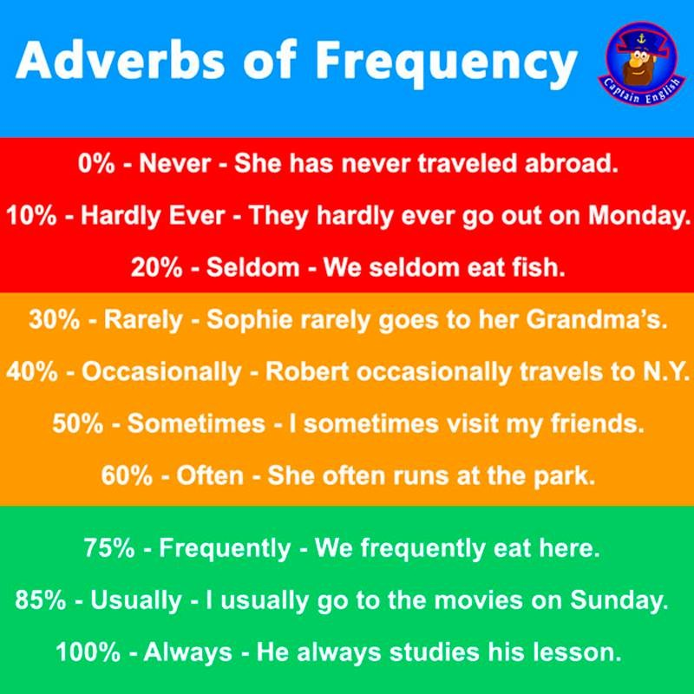



*30*

EVER: to ask a question about frequency. It means "at any time." Adverbs of frequency tell HOW OFTEN an action is repeated. They are commonly used with present or past tense. Use "ever" to ask a question.

##### Placement of adverbs of frequency. Frequency adverbs are placed:

BEFORE the main verb unless the verb is BE.

I always study in the library when I have an exam.

AFTER the verb "Be".

I am always tired after classes.

Rule: Never put an adverb between the main verb and its object. Wrong: I give almost always the dog a bath on Saturday.

Correct: I almost always give the dog a bath on Saturday.

##### Adverbs of frequency in questions

Rule: In questions, put the adverb of frequency after the subject. Examples:

Do you always sit in the same seat? Is Jim never going to stop talking?

Adverbs of Frequency in Short answers

Rule: In a short answer, put the frequency adverb between the subject and the verb for ALL verbs.

Examples:

Do you ever go hiking? Yes, I sometimes do.

Is your father ever sick? Yes, he occasionally is. Now it’s your turn:



*31*

## - Rewrite the sentence using the adverb in parentheses.

1. Do you have vacation? (ever)
2. When do you go to bed? (generally)
3. How often does he call you? (usually)
4. Do you travel during your vacation? (sometimes)

## - Where can you put the adverb in this sentence? Indicate the location with an "X".

1. I ask questions in that professor's class. (Never)
2. An impolite person interrupts others while they are speaking. (always)
3. Bad drivers park their car correctly. (rarely)
4. It is cold in the spring in Miami. (seldom)



*32*

## - There are some sentences where the adverb is in the correct place and in other sentences it isn’t. Correct the sentences that are wrong.

1. John is always late.
2. John is late always.
3. John always is late.
4. He never does it well.
5. He does it never well.
6. Never he does it well.
7. I seldom work hard.
8. I work hard seldom.
9. I work seldom hard.

## – Put the sentences in the correct order:

1. always – buy – do – clothes – you – the – at – store?
2. eat – I – food – never – Chinese
3. ever – Paris? – gone – you – have – to
4. go – they – rarely -movies – weekends – on – the – to
5. sometimes – kids – together – the – play



*34*



SONG 5

**Story of My Life by One Direction**

**Learning Focus**: Weather. Synonyms.



**About One Direction**

One Direction were a boy band that became very famous after singing in the program The X Factor in 2010. The band were formed by Niall, Liam, Payne, Harry and Louis. Story of My Life is one among their great hits and in the videoclip you can see a little bit about the story of the band. What is the story of your life?



*35*

# Activities

## - Listen to the song and complete the lyrics:

Written in these walls are the

That I can't explain

I leave my heart open

But it stays right here empty for

She told me in the

She don't feel the same about us in her bones It seems to me that when I die

These words will be written on my

## – Circle the correct alternative:

And I'll be gone gone **NIGHT / TONIGHT**

The ground beneath my **FEET / LEED** is open wide The way that I've been holding on too **TIGHT / CRY** With nothing in **BETWEEN / IN**

## – Put the sentences in the correct order:

( ) I drive all night to keep her warm and time ( ) The story of my life I take her home

( ) The story of my life I give her hope



*36*

( ) Until she's broke inside ( ) I spend her love

( ) Is frozen (the story of, the story of)

( ) The story of my life (the story of, the story of)

## – Circle the correct alternative:

Written on these **BALLS / WALLS**

Are the colors that I can't **CHANGE / CAGE**

Leave my heart open

But it stays right here in its **CHANGE / CAGE**

I know that in the morning **BOW / NOW**

I see us in the light upon a hill Although I am **CHOSEN / BROKEN** My heart is untamed, still

## – Put the words in the sentences in the correct order:

tonight gone And be gone I'll

is The fire my feet burning beneath bright

way The that been holdin' on so tight I've

between nothing in With



*37*

## – Put the sentences in the correct order:

( ) I drive all night to keep her warm and time ( ) I spend her love

( ) The story of my life I take her home ( ) Is frozen (the story of, the story of) ( ) Until she's broke inside

( ) The story of my life I give her hope

( ) The story of my life (the story of, the story of)

## – Complete:

And I've been waiting for this to come around But baby running you

Is like chasing the

The story of my life I take her home

I drive all to keep her warm and time Is frozen

The story of my I give her hope (give her hope) I spend her love

Until she's broke (until she's broke inside) The story of my life (the story of, the story of)

The story of my life

The story of my life (the story of, the story of) The story of my life



*38*

## - Look for the name of these images in the song:

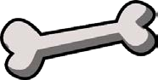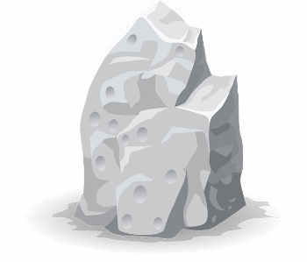

1. - Try to find the synonyms of these words in the song:
2. Pursueing:
3. Keeping:
4. View:
5. Looking forward:
6. Narrative:
7. **- Relate the words to the correct climate:**

RAINY – FROZEN – WINDY - WARM

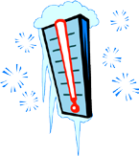



*39*



SONG 6

# Love Yourself by Justin Bieber

**Learning Focus**: Simple Present. Simple Past.



**About Justin Bieber**

Justin Bieber is a Canadian singer. A manager discovered him through a video posted on YouTube in 2008. During his famous life, he has had ups and downs. Love Yourself is one of his great and latest hits. It looks like he has found again the way to success.



*40*

# Activities

## – Listen and put the sentences in the correct order:

( ) You think you broke my heart, oh, girl for goodness' sake ( ) And all the clubs you get in using my name

( ) You think I'm crying on my own. Well, I ain't ( ) For all the times that you rain on my parade

## – Circle the correct word:

And I didn't wanna **BRIGHT / WRITE** a song

'Cause I didn't want anyone thinking I **STILL / WILL** care. I don't, But you still hit my phone up

And, baby, I be movin' on

And I **THING / THINK** you should be somethin' I don't wanna hold back, Maybe you **SHOULD / MUST** know that

## – Complete with the missing words:

My mama don't like you and she likes

And I never like to that I was wrong And I've been so caught up in my , Didn't see what's going on

But now I know,

I'm better on my own



*41*

## – Cross out the extra word:

*CHORUS:*

'Cause if you like the way you don’t look that much Oh, baby girl, you should go and love yourself

And if you still think that I'm still holdin' on to somethin' You should not go and love yourself

## – Put the sentences in the correct order:

( ) And every time you told me my opinion was wrong ( ) The only problem was with you and not them

( ) And tried to make me forget where I came from ( ) And when you told me that you hated my friends

## – Circle the correct word:

And I didn't wanna **BRIGHT / WRITE** a song

'Cause I didn't want anyone thinking I **STILL / WILL** care. I don't, But you still hit my phone up

And, baby, I be movin' on

And I **THING / THINK** you should be somethin' I don't wanna hold back, Maybe you **SHOULD / MUST** know that

## – Complete with the missing words



*42*

My mama don't like you and she likes

And I never like to that I was wrong And I've been so caught up in my , Didn't see what's going on

But now I know,

I'm better on my own REPEAT CHORUS

For all the times that you made me feel small I fell in love. Now I feel nothin' at all

And never felt so low when I was vulnerable Was I a fool to let you break down my walls?

REPEAT CHORUS

## – All the sentences below are in the past tense. Can you change them into the present tense?

1. Was I a fool to let you break down my walls?
2. For all the times that you made me feel small.
3. Because I didn't want anyone thinking I still care.
4. And tried to make me forget where I came from.
5. And when you told me that you hated my friends



*43*

## – Relate the words to their meaning:

1. hold back ( ) A matter or situation regarded as unwelcome or

harmful and needing to be dealt with and overcome.

1. fool ( ) Develop a deep romantic attachment to someone.
2. break down ( ) Hesitate to act or speak
3. problem ( ) A silly person.
4. fall in love ( ) Lose control of one's emotions when in a state of

distress.

## – To ask questions in the simple past, you must use the auxiliary Verb ‘DID’. Don’t forget when you ask a question in the past tense, the Spelling of the verb is in the infinitive form, without ‘to’.

1. You tried to make forget where I came from.
2. You made me feel small.
3. You told me that you hated my friends.
4. You broke my heart.



*44*

## – Now let’s change these same sentences into the negative form. In the simple past tense, use the auxiliary verb ‘didn’t’ to change a sentence into negative. The main verb is also spelling in the infinitive form, without ‘to’.

1. You tried to make forget where I came from.
2. You made me feel small.
3. You told me that you hated my friends.
4. You broke my heart.



*45*