

SONG 7

# Perfect Illusion by Lady Gaga

 **Learning Focus**: Simple Past.

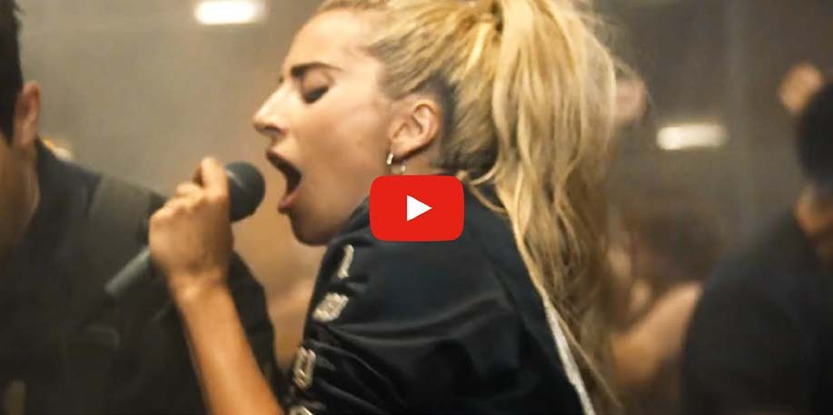

**About Lady Gaga**

Lady Gaga, actually Stefani (it’s her real name), is an American Singer, Songwriter and Actress. She has been known by the ways she dresses. At the 2010 MTV Video Music Awards she wore a dress made of raw beef. Lady Gaga was very criticized because of that. Nowadays she is more well known by her songs than by her clothes.



*46*

# Activities

## – Complete with the words you listen:

Tryin' to get

Pressure's takin' its toll

Stuck in the zone Now I just want you alone

My guessing game is Way too real to be Caught up in your show

Yeah, at least now I

## – Cross the extra words out:

It wasn't my love, it wasn't love

It was just a perfect illusion (perfect illusion) Mistaken for one love, it wasn't love

It was just a perfect illusion (perfect illusion) You were only a perfect illusion

## – Put the sentences in the right order:

( ) Maybe you're just a dream ( ) I felt you touchin' me



*47*

( ) I still feel the blow

( ) High like amphetamine ( ) But at least now I know ( ) I don't need eyes to see

( ) That's what it means to crush ( ) Now that I'm wakin' up

## – Complete with the vowels:

t w sn't l v , t w sn't l v

t w s p rf ct ll s n (p rf ct ll s n) M st k n f r l v , t w sn't l v

t w s p rf ct ll s n (p rf ct ll s n)

## – Put the letters in order:

It was a perfect illusion It was a perfect illusion

Mistaken for love Mistaken for love Mistaken for love

I'm EVOR the show

Yeah at TELAS now I know

It wasn't love, it wasn't love

It was a perfect illusion (perfect illusion) Mistaken for love, it wasn't love

It was a perfect illusion (perfect illusion) (Aah) you were a perfect illusion



*48*

(Aah) it was a perfect illusion It was a perfect illusion

Somewhere in all the confusion

It was a perfect illusion, illusion (illusion)

It was perfect illusion Somewhere in all the confusion You were so perfect

You were a, you were a perfect illusion

## – Complete the sentences with WAS or WERE:

1. Mary my student when she was eight.
2. The dogs barking last night.
3. The mistakes obviously.
4. I don’t know why you acting so weird last night.
5. The children sleeping when their dad arrived.
6. She a perfect singer before the accident.
7. That boy running away from his parents.
8. They married before they had kids.
9. Jonny and I friends before dating.
10. I very anxious when I a kid.
11. The mice trying to eat the cake.



*49*

## ) There are two forms of the verb to be in the past: was and were. When you have a sentence with was or were, you don’t use DID as an auxiliary verb to ask questions. You must use was or were. Just put it in front of the pronoun. Let’s try! Change the sentences below into interrogative:

1. It was a perfect illusion.
2. You were so perfect.
3. It was love.
4. You were a perfect illusion.

## 8) The same thing happens into the negative form. When you have a sentence into the simple past with was and were, you don’t use ‘DIDN’T’ to change it into negative. You just need to use not after the verb to be or the contractions form wasn’t and weren’t. Let’s see. Change the sentences now into the negative form:



*50*

1. It was a perfect illusion.
2. You were so perfect.
3. It was love.
4. You were a perfect illusion.



*51*



SONG 8

# Photograph by Ed Sheeran

### **Learning Focus**: Simple Present. Simple Past. Simple Future. Wh Questions.

Prepositions. Reading Comprehension.

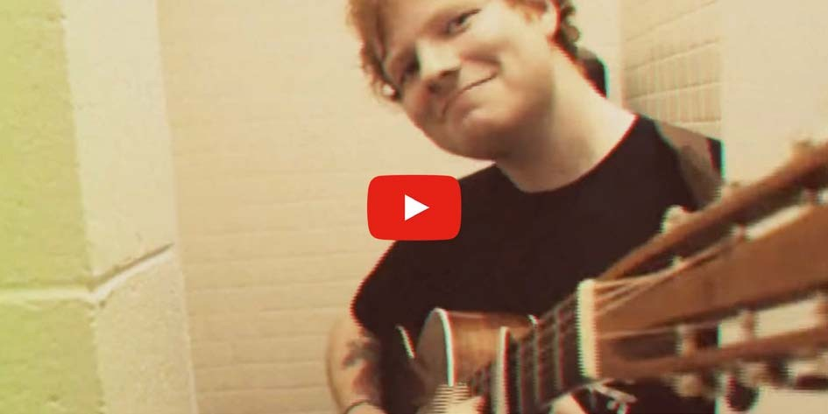

**About Ed Sheeran**

Edward Christopher Sheeran, who was born in February 17th, 1991, is an English singer-songwriter, guitarist and record producer. He was born in Halifax, West Yorkshire, and raised in Framlingham, Suffolk. He attended the Academy of Contemporary Music in Guildford, Surrey, as an undergraduate from the age of 18 in autumn 2009. In early 2011, Sheeran independently released the extended play, No. 5 Collaborations Project. In 2012, Sheeran won the Brit Awards for Best British Male Solo Artist and British Breakthrough Act.



*52*

# Activities

## – Circle the correct word:

**LOVE/ LOVING** can hurt, loving can hurt sometimes But it's the only thing that I **NOW / KNOW**

When it gets hard, you know it can **GET / GOT** hard sometimes It is the only **THING / THINK** that makes us feel alive

We keep this **LOVE/ LIKE** in a photograph

We made **THESE/ THIS** memories for ourselves Where our eyes are never **CLOSE / CLOSING** Hearts are never **BROKEN / OVEN**

And time's forever frozen **STILL / WHEEL**

1. **– Complete with the words you listen:**

So you can me

Inside the pocket of your jeans Holding me 'til our eyes meet

You won't ever be alone, wait for me to home

Loving can , loving can mend your soul And it's the only thing that I know, know

I swear it will get ,

Remember that with every of you

Hm, and it's the only thing we take with us when we die

Hm, we keep this in this photograph We made memories for ourselves



*53*

Where our eyes are never

Hearts were never broken And time's forever frozen still

So you can me

Inside the pocket of your jeans Holding me 'til our eyes meet You won't ever be alone

And if you hurt me

That's okay baby, only words bleed Inside these pages you just hold me And I won't ever let you go

Wait for me to come home Wait for me to come home Wait for me to come home Wait for me to come home

1. **– Put the sentences in the right order:**

( ) And I won't ever let you go

( ) Next to your heartbeat where I should be ( ) Inside these pages you just hold me

( ) Keep it deep within your soul ( ) And if you hurt me

( ) So you can fit me

( ) Well, that's okay baby, only words bleed

( ) Inside the necklace you got when you were sixteen

When I'm away, I will remember how you kissed me Under the lamppost back on Sixth street



*54*

Hearing you whisper through the phone, "Wait for me to come home."

## – Now check out these sentences from the song. Are they in the Present (P), Past (PA) or Future (F) Tense? Read and decide.

1. ( ) Keep it deep within your soul
2. ( ) You just hold me
3. ( ) I swear it will get easier
4. ( ) Inside the necklace you got when you were sixteen
5. ( ) I will remember how you kissed me
6. ( ) Wait for me to come home

## – Complete the sentences using WHEN, WHERE, WHAT, WHO or WHOSE:

1. do you live?
2. are you from?
3. car is this?
4. is your math test?
5. did you get for your birthday?
6. is that man standing over there?
7. are you going to travel?
8. house is this?



*55*

1. are your parents?
2. are you planning to do on Saturday?

## – Have you listened to a song by Ed Sheeran before? What do you know about him? Read again the text about him and answer the questions below.

1. When and Where was Ed Sheeran born?
2. When did he win the ‘Brit Awards’?
3. Which music school did he go to?

## 7) Now complete with the prepositions IN or ON:

1. Wednesday
2. Autumn
3. Winter

d) 2011

1. March
2. February 17th, 1991
3. September 9th
4. Monday



*56*



SONG 9

# The Scientist by Coldplay

**Learning Focus**: Indefinite Pronouns. Greetings.



**About Coldplay**

Coldplay are a British rock band and they were formed in 1996. They are very famous and their songs have been on the top parades for many times. The lead singer, Chris Martin, was married to the actress Gwyneth Paltrow. She participated in one of his albums ‘Adventure of a Lifetime’.



*57*

# Activities

## – Listen to the song and complete the lyrics:

Come up to you, tell you I'm sorry. You don't know how lovely you are

I had to find you, tell you I you And tell you I you apart

Tell me your secrets, and ask me your questions Oh let's go back to the Running in circles, coming up tails

Heads on a science apart

## – Organize the words in sentences:

it Nobody easy said was

shame such a for part us to It's

said it easy was Nobody

hard be No ever said it would one this

Oh me to start the take back

## – Listen and complete:



*58*

I was just guessing at and figures Pulling the apart.

Questions of science, science and progress Don't speak as loud as my heart.

Tell me you love me, back and haunt me, Oh, when I rush to the start

Running in , chasing in tails Coming back as we are.

## – Circle the correct option:

Nobody said it was **PEACE / EASY**

It's such a shame for us to **PART / DART**

Nobody **TOLD / SAID** it was easy.

No one ever said it would be so **PART / HARD**

I'm going back to the **STAFF / START**

## – Check the other ways to say “I’m sorry’:

( ) I’m glad to see you. ( ) It’s my fault.

( ) I’m terribly sorry. ( ) I don’t care.

( ) Please, forgive me.

( ) Please, accept my apologies. ( ) I’m happy to do it.



*59*

## – Check the other ways to say “How are you?”:

( ) What’s your phone number. ( ) What’s up?

( ) How are you keeping? ( ) How old are you?

( ) How is it going?

( ) How have you been?

( ) How do you go home?

## – Look up the name of these pictures in the lyrics:



1. 2.

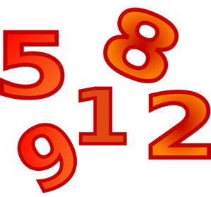

3. 4.



*60*

## – Complete the sentences using SOMEBODY, NOBODY or ANYBODY:

1. I didn’t know that. told me!
2. I don’t see in the library. What happened?
3. It’s was very fast. There was in line.
4. told me you are dating Eric. I’m very happy for you.
5. Did tell you about the party next week?
6. I can ask to help us to do that.
7. Donna couldn’t talk to about it. I’m sorry.
8. Will help to pay her present?
9. Does want to talk about what happened here?
10. The poor woman has to help her.

## - Fill in the blanks. Use SOME, ANY or NO:

1. Do you have question ?
2. They want to sell fish at the market. 3-I´m not going to buy fruit today.

4- women are cooking lunch now. 5-Are there spoons in the kitchen?

1. There aren’t classes today. It’s Sunday.
2. I’m going to buy oranges for breakfast.



*61*

1. Is there of your friends coming over? 9-We don’t have friends in L.A.

10- Susan is very lonely. She has friends.



*62*



SONG 10

# Love Story by Taylor Swift

**Learning Focus**: Present Perfect. Adverbs. Masculine and Feminine Nouns.



**About Taylor Swift**

At the beginning of her career, Taylor Swift pursued a career in country music, but nowadays she is well-known by her pop songs. Love Story is part of her album Fearless. She won four Grammy Awards for it. Taylor Swift writes a lot of songs about her personal life. She has written about Rihanna, Harry Styles, Kim Kardashian and Kanye West. That’s why she’s always involved in controversies.



*63*

# Activities

## - Listen to the song and complete with the words from the box.

alone – away – flashback – lights - crowd – staircase – both – save – mess – left – town – garden – marry – tired - ring

We were young when I first saw you I close my eyes and the starts

I'm standing there, on a balcony in summer air See the , see the party, the ball gowns See you make your way through the And say "hello", little did I know

That you were Romeo, you were throwing pebbles And my daddy said "Stay from Juliet" And I was crying on the

Begging you please don't go

And I said

Romeo, take me somewhere we can be I'll be waiting, all there's to do is run

You'll be the prince, and I'll be the princess It's a love story, baby, just say yes

So I sneak out to the to see you We keep quiet, cause we're dead if they knew So close your eyes

Escape this for a little while



*64*

Oh, oh

Cause you were Romeo, I was a scarlet letter And my daddy said "Stay away from Juliet" But you were everything to me

I was begging you please don't go

And I said

Romeo, take me somewhere we can be alone I'll be waiting, all there's left to do is run

You'll be the prince and I'll be the princess It's a love story, baby, just say yes

Romeo, me, they're trying to tell me how to feel This love is difficult, but it's real

Don't be afraid, we'll make it out of this

It's a love story, baby, just say yes

I got of waiting, wondering if you were ever coming around My faith in you was fading when I met you on the outskirts of town

And I said

Romeo, save me, I've been feeling so alone I keep waiting for you, but you never come Is this in my head? I don't know what to think

He knelt to the ground and pulled out a and said...

me, Juliet, you'll never have to be alone I love you, and that's all I really know

I talked to your dad, go pick out a white dress It's a love story, baby, just say yes

Oh oh oh Oh oh oh

Cause we were both young when I first saw you



*65*

## – Question:

Do you know who were Romeo and Juliet?

## – Relate the masculine to the feminine nouns:

* 1. Man ( ) madam
  2. Prince ( ) wife
  3. Boy ( ) aunt
  4. Bridegroom ( ) woman
  5. Hero ( ) niece
  6. Sir ( ) princess
  7. Brother ( ) sister
  8. Dad ( ) girl
  9. Uncle ( ) bride
  10. Nephew ( ) heroine
  11. Husband ( ) mom

## – Try to explain the meaning of:

Stay away:

Begging:



*66*

Flashback:

## – Complete with the Present Perfect:

1. you to the United States? (be)
2. I to the movies lately. (to go – not)
3. He never before. (to drive)
4. The party already . (to finish)
5. Martha this book twice. (to read)
6. They never so much! (to drink)
7. The baby already . (to sleep)
8. He already his exercises. (to do)
9. She for me since 2010. (to work)

## - Complete the table using the Present Perfect:

|  |  |  |
| --- | --- | --- |
| AFFIRMATIVE | NEGATIVE | INTERROGATIVE |
| He has written a letter. |  |  |
|  | They have not stopped. |  |
|  |  | Have we danced? |
| She has worked. |  |  |
|  | Andy has not slept. |  |

1. **– Complete with FOR, SINCE or AGO:**
2. I've studied piano 10 years.
3. They've practiced soccer they were children.
4. We have known each other
5. We moved to California three months

a long time.

.

1. They have tried to win the contest years.



*67*

1. Leslie has lived in Ohio 1982.
2. Melissa arrived at the office an hour .
3. Tom and Paul have known each other 2001.
   1. Two days we decided to change our strategy.

j) 2005 we have tried to get new clients.

## – Complete with ALREADY or YET:

1. He hasn't called us .
2. They have mailed the check.
3. Is it time for us to leave ?
4. John has bought the tickets for the game.
5. We have signed the contract.
6. But you haven't visited Rome .
7. We have been to Mexico three times.
8. Has John gotten his new car ?
   1. Have the police found the thief ?

j) The plane has left the airport.