

*68*



SONG 11

# Don’t Speak by No Doubt

**Learning Focus**: Imperative. Antonyms. Opposites.



**About No Doubt**

No Doubt was a famous American rock band. The lead singer was Gwen Stefani and it was her who wrote ‘Don’t Speak’, one of the greatest hit of the band. The verses of this song celebrated Gwen's long-standing relationship with her bassist, Tony Kanal, but when they broke up she changed some lyrics and it became a sad song.



*69*

# Activities

## – Listen to the song and complete the words just using vowels:

Y and m

W s d t b t g th r

v ry d y t g th r lw ys

## – Write the full sentences:

that I’m losing my best friend

This could be the end

## – Complete with the missing words:

It looks as though you’re go And if it’s ,

Well I don’t want to

## – Put the chorus in the correct order:

( ) Don’t tell me ’cause it hurts

( ) I know just what you’re saying



*70*

( ) I know what you’re thinking ( ) I don’t need your reasons

( ) So please stop explaining ( ) Don’t speak

( ) Don’t tell me ’cause it hurts ( ) Don’t speak

## – Complete:

Our

They can be inviting

But some are

Mighty frightening

As we die, both you and I

With my head in my

I sit and cry

## 6– Put the chorus in the correct order:

( ) So please stop explaining ( ) Don’t tell me ’cause it hurts ( ) Don’t speak

( ) I know what you’re thinking ( ) I don’t need your reasons

( ) Don’t speak

( ) Don’t tell me ’cause it hurts

( ) I know just what you’re saying

It’s all ending

I gotta stop pretending who we are.

You and me

I can see us dying, are we?

## – Put the chorus in the correct order:

( ) Don’t tell me ’cause it hurts ( ) Don’t tell me ’cause it hurts ( ) I know what you’re thinking ( ) So please stop explaining

( ) Don’t speak

( ) I know just what you’re saying ( ) Don’t speak

( ) I don’t need your reasons

Don’t speak

I know what you’re thinking And I don’t need your reasons Don’t tell me ‘cause it hurts Don’t tell me ‘cause it hurts

I know what you are saying So please stop explaning Don’t speak

Don’t speak Don’t speak

I know what you’re thinking I don’t need your reasons



*72*

I know you’re good I know you’re good

I know you’re real good oh La da da da da da

La da da da da da Don’t, don’t

Ohh Ohh

Hush me hush me darling Hush me hush me darling

Hush me hush me, don’t tell me ’cause it hurts (2x)

## – Complete the Crossword Puzzle with the words from the song.

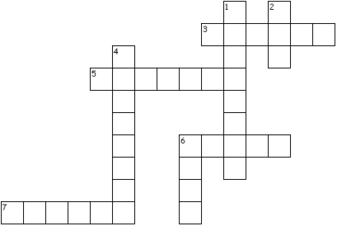

ACROSS

3. The opposite of finding.

1. Synonym of accept.
2. Synonym of say.
3. The opposite of never.

DOWN

1. The opposite of separate.
2. The opposite of live.

4. Remember, recall impressions.

6. The opposite of go.

## – Look at these tips for a good health, then write the sentences under the correct picture.

1. Read books.
2. Don’t drink alcoholics beverages.
3. Don’t smoke.
4. Eat fruit.
5. Sleep 8 hours a day.
6. Practice sports.
7. Walk.
8. Go out with your friends.

|  |  |  |  |
| --- | --- | --- | --- |
|  |  |  |  |
|  |  |  |  |
|  |  |  |  |
|  |  |  |  |

## – Complete with the imperative of the verbs in parentheses:

1. Jessica, the window, please. (to open)
2. “We are driving home”. alcohol. (to drink - not)
3. “I’m hungry”. something. (to eat)
4. to me this way! (to talk – not)
5. Teacher, the door, please. (to close)
6. chocolate before lunch! (to eat – not)

## – Read the sentences and correct the wrong ones:

1. Not play football in the yard.
2. Do your homework.
3. Talk not during the class.
4. Don’t speak to him.
5. Go to your room right now.



SONG 12

# Ironic by Alanis Morissette

**Learning Focus**: Simple Present. Simple Past.

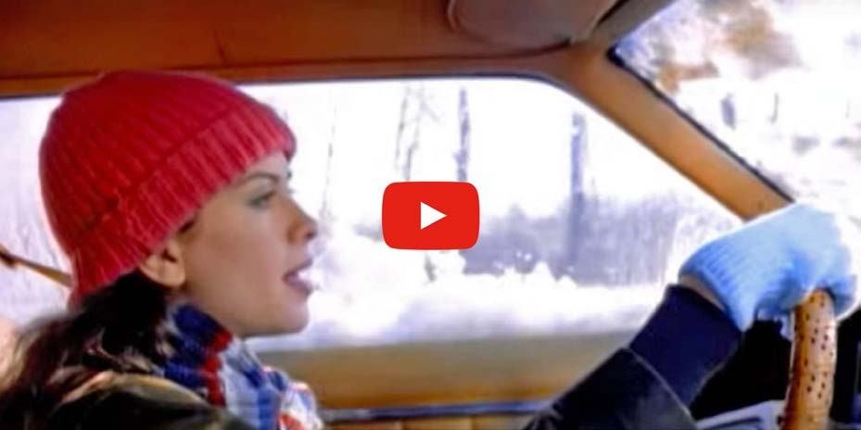

**About Alanis Morissette**

Alanis Morissette is a Canadian singer who became very famous in the nineties. Ironic is one of her great hits. In this song, she talks about ironic situations like receiving a good advice that you didn’t take or having a free ride when you have already paid. Has anything ironic ever happened to you?

# Activities

## – Complete with the verbs in the past:

An old man ninety-eight (to turn)

He the lottery and the next day (to win – to die)

It's a black fly in your Chardonnay

It's a death row pardon two minutes too late Isn't it ironic... don't you think?

## – Relate the sentences:

1. It's like rain ( ) that you just didn't take
2. It's a free ride ( ) on your wedding day
3. It's the good advice ( ) it figures
4. Who would've thought ( ) when you've already paid

## – Complete with the verbs in the Past Tense:

Mr. Play it Safe afraid to fly (to be)

He

He

And as the plane

his suitcase and kissed his kids good-bye (to pack) his whole damn life to take that flight (to wait)

down he thought (to crash)

"Well, isn't this nice."



*77*

And isn't it ironic ... don't you think?



*78*

## – Write the sentences in the correct order:

like on It's your rain day wedding

already a free paid ride It's you've when

It's take good that you the didn't advice just

figures would've Who thought it

## – Listen and complete:

Well life has a way of sneaking up on you

when you everything's okay

and everything's going right And life has a funny way

of helping you

when you think everything's gone wrong

and everything blows up in your

A traffic jam when you're already late

A no-smoking sign on your cigarette break

It's like 10,000 when all you need is a knife

It's meeting the man of my dreams

And then meeting his beautiful

And isn't it ironic... don't you think

A little too ironic.. and yeah I really do think...

1)

2)

3)

4)

Well life has a funny way of sneaking up on you And life has a funny, funny way of helping you out Helping you out

## 7 – Relate the verbs to the pictures:

Crash – Die – Win – Pack - Wait

|  |  |
| --- | --- |
|  |  |
|  |  |
|  |  |
|  |  |
|  |  |

## activity 7:

1. He didn’t in the car accident. He is at the hospital.
2. Did you see that car ? It was horrible!
3. We are going to tonight and going to travel tomorrow.
4. I don’t like to for him.
5. They always when they play together.

## 9 – Fill in the brackets with the verbs below in the correct form of the Simple Present:

TALK - LEAVE - GO OUT - TAKE - WRITE - BRUSH - WAIT - CHECK - GO - HAVE - WALK - WATCH - DISCUSS - WAKE UP

Janice every morning at seven o’clock. She a shower and her teeth. Then she to the kitchen to prepare her breakfast. She usually a cup of coffee and some bread. She leaves home at eight o’clock, to the bus stop and for her bus to arrive. When she gets to work, she her e-mails and notes. She usually goes to a meeting with other employees. During the meeting, they all what they have to do that day. Janice lots of reports for her boss, and she also to clients. At five o’clock, Jessica the office and takes another bus to go home. She some series every night, and sometimes she with friends to eat something.

## (You may not use all of them):

do – does - don't - doesn't – is - isn't – are - aren't

1. you like chocolate?

Yes, I . I think everybody .

1. Kim from Canada?

Nope, she from the United States.

1. We like the beach very much this time of the year. We prefer the mountains.

Why that?

Because it too cold to go to the beach during winter.

1. How often you go to the cinema?

I go to the cinema once a moth. By the way, We going this weekend. you want to go with us?

1. Daniel at home. He at school. But he arriving soon. Why? you need to talk to him?

No, I .



*82*



SONG 13

**Black or White by Michael Jackson**

**Learning Focus**: Days of the Week. Months of the Year. Feelings. Colors.



**About Michael Jackson**

Michael Jackson died in 2009, but his songs are still played and known worldwide. He was known as The King of Pop. Even though he was a controversy person, his songs were on the top parades. Black or White gives a great message saying the skin color of a person really doesn’t matter.



*83*

# Activities

## – Listen to the song and complete:

I took my baby on a bang Boy is that with you?

Yes, we're one and the same Now I believe in miracles

And a miracle has happened

But, if you're thinking about my baby It don't matter if you're black or white

They print my in the Saturday Sun I had to tell them

I ain't second to none

And I told about

An it's true, either you're wrong or you're right

But, if you're thinking about my baby It don't matter if you're black or white

## – Put the sentences in the correct order:

( ) I am tired of this stuff ( ) I ain't scare of nobody

( ) I am tired of this business

( ) Girl, when the going gets mean ( ) Sew when the going gets rough



*84*

( ) I am tired of this devil

( ) I ain't scared of no sheets

( ) I ain't scared of your brother

( ) Causing grief in human relations

( ) I'd rather hear both sides of the tale ( ) See, it's not about races

( ) I've seen the bright get duller

( ) Protection for gangs, clubs and nations ( ) Just places, faces

( ) Where your blood comes from ( ) It's a turf war on a global scale ( ) Is where your space is

( ) I'm not going to spend my life being a color

## – Complete:

Don't tell me you agree with me

When I saw you kicking dirt in my

But, if you're thinking about my baby It don't matter if you're black or white

I said if you're thinking of being my baby It don't matter if you're black or white

I said if you're thinking of being my

It don't matter if you're black or white It's black, it's white

It's tough for you to get by It's black , it's white

## – Put the days of the week in the correct order:

Saturday – Tuesday – Thursday – Sunday – Monday – Friday – Wednesday

## – Put the months of the year in the correct order:

March – December – April – June – January – November – July – February – May – August – October – September

## – Choose the words for each emojis below:

##### Scared Tired Happy Sad Angry Hungry



1.



*85*



4.

2.



5.

3.



6.



*86*

## – Now relate the antonyms:

1. boy ( ) right
2. true ( ) girl
3. agree ( ) dark
4. bright ( ) false
5. wrong ( ) disagree

## – Mixing Colors. Do you know the color results when you mix these colors?

**RED YELLOW**

**RED BLUE**

**BLUE YELLOW**

**BLACK WHITE**

**RED WHITE**



*87*



SONG 14

# Friday I’m In Love by The Cure

**Learning Focus**: Color Idioms. Feelings. Days of the Week. Reading Comprehension.

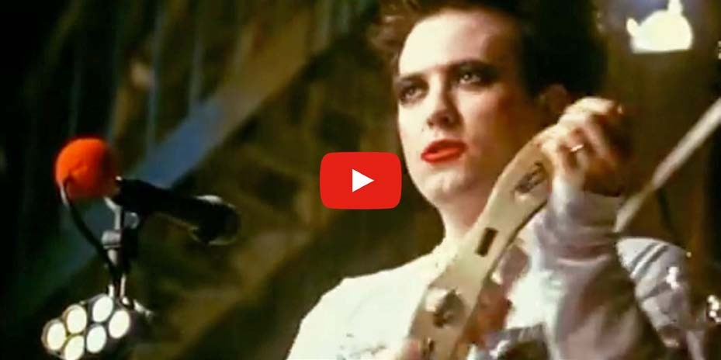

**Friday**

People usually get more excited when the weekend is coming. This song isn’t different. According to it, the days from Monday to Thursday aren’t so important as Friday. Do you think Friday is a good day to fall in love?



*88*

# Activities

## – Listen to the song and complete the lyrics:

I don't care if Monday's Tuesday's and Wednesday too Thursday, I don't about you

It's Friday, I'm in love

Monday you can fall apart

Tuesday, Wednesday break my

Thursday doesn't even

It's Friday, I'm in love

Saturday wait

And Sunday always too late But Friday never hesitate...

I don't care if Monday's Tuesday, Wednesday - heart attack Thursday, never looking It's Friday, I'm in love

Monday you can hold your

Tuesday, Wednesday stay in bed

Oh Thursday, watch the walls

It's Friday, I'm in love

Saturday wait

And Sunday always too late But Friday never hesitate...

## – Now number the sentences in the correct order:

( ) And just smiling at the sound ( ) It's a wonderful surprise

( ) To see your shoes and your spirits rise ( ) And as sleek as a shriek

( ) Spinning round and round ( ) Dressed up to the eyes

( ) Always take a big bite ( ) It's Friday

( ) It's such a gorgeous sight ( ) Throwing out your frown

( ) You can never get enough ( ) Enough of this stuff

( ) I'm in love

( ) To see you eat in the middle of the night

## – Complete:

I don't care if Monday's Tuesday's and Wednesday too Thursday I don't care about you

It's Friday I'm in love

Monday, you can fall apart

Tuesday, Wednesday break my

Thursday doesn't even

It's Friday I'm in love

## – Read the text and answer the questions:

##### Colors and Feelings

Did you know you can tell how you feel using colors? When someone says “I’m blue” it doesn’t mean the person is blue. It means the person is sad. Or when you hear someone saying they are green with envy it means they are really jealous. Or if you are in the red, you are in debt, without money. There are a lot of color idioms. Check the list below:

|  |  |  |
| --- | --- | --- |
| **Idiom** | **Meaning** | **Example** |
|  |  |  |
| Beet red | When your face turns red because of an embarrassing  situation. | She turned beet red when she saw he was looking at her at the  party. |
| Black market | Place where goods or money are illegally bought and sold. | Did you buy this at the black market? Are you crazy? You can get in  trouble! |
| Black out | To pass out; to  become unconscious. | After he felt, he had a  black out. |
| Black sheep | A bad member of the group. | That girl is the black sheep of her family. She doesn’t do  anything right. |
| Golden opportunity | Perfect chance or opportunity. | This is a golden opportunity for you to increase your  business. |

|  |  |  |
| --- | --- | --- |
| The Green light | Permission. | The green light was given to him to do whatever he wanted at  the company. |
| In the dark | Unaware; uninformed. | The parents were in  the dark about their son situation. |
| Out of the blue | Unexpectedly. | She called me out of  the blue. I couldn’t say no to her. |
| See red | Be very angry. | They saw red when they caught their  daughter lying. |
| True colors | A person’s true  atitude. | Can you see her true  colors now? |
| White lie | An innocent lie to not hurt someone’s feelings. | She asked if I liked her dress. I said yes. I couldn’t say no. It’s just  a white lie. |

## - Now choose T (true) for true sentences and F (false) for false sentences according to the text:

( ) Out of the blue has the same meaning as something you weren’t expecting. ( ) When you tell an innocent lie you are saying a black lie.

( ) When you are happy you can say you are blue. ( ) She is very rich. She is always in debt.

( ) When there is an embarrassing situation, a person can be beet red.

( ) People say it’s a golden opportunity when someone has a great opportunity.



*92*

## – Replace the underline words for color idioms:

1. She showed her true attitude at the meeting.
2. I was not informed about this situation.
3. She wasn’t feeling well and suddenly, she passed out.
4. The school gave him permission to do it.
5. **– Besides saying “it’s Friday, I’m in love”, this song shows the days of the week. Can you write them in the correct order? Don’t forget that the days of the week always start with capital letters.**



*93*



SONG 15

# With or Without You by U2

**Learning Focus**: Definite and Indefinite Articles. Weather. Body Parts.



**About U2**

U2 are an Irish rock band from Dublin formed in 1976. The members of the group are: Bono, who is the lead singer and plays the guitar. The Edge, who is back vocal, plays the guitar and the keyboards. Adam Clayton, who plays the bass and the guitar. Finally, Larry Muller Jr., who plays the drums and percussion. The group does live performances and are still famous nowadays.



*94*

# Activities

## – Listen to the song and complete the lyrics:

See the set in your eyes See the twist in your side I for you

Sleight of and twist of fate

On a of nails, she makes me wait And I without you

With or without you With or without you

Through the , we reach the shore You it all, but I want more

And I'm for you

*CHORUS*

With or without you With or without you I can't live

With or without you

And you give yourself away And you give yourself away And you give

And you give

And you give yourself away

My hands are , my body bruised She's me with

Nothing to and Nothing left to



*95*

And you give yourself away And you give yourself away And you give

And you give

And you give yourself away Repeat Chorus

## – Read the text again about U2 and choose T for true and F for false sentences:

( ) U2 is a hip hop band.

( ) The band is from Dublin.

( ) They started their career in nineteen-seventy-six ( ) The band has five members.

( ) Bono is the lead singer.

( ) They don’t do live performances anymore.

## – Circle the words related to the weather:

Fate – side – storm – eyes – sun – with – without – wind – rain

## – Circle the words related to the body parts.

Arm – storm – side – eyes – hands – fate – yourself – away



*96*

## – Relate the antonyms:

( ) away a - keep

( ) with b - close

( ) give c - without

( ) tied d – separated

## – Complete with the right article A or AN:

good artist

hour

Architect

house

umbrella

honest man

woman

green apple

apple

story



*97*

elevator

airplane

bike

## – Complete the sentences using A or An.

1. John is terrible architect.
2. My daughter is engineer and my son is teacher.
3. We will have to wait for hour to see the movie.
4. There was person waiting for you outside.
5. She is English student.
6. Do you have umbrella?
7. We watched European movie last night. It was wonderful movie.
8. My dad is honest man.



*98*



SONG 16