

*18*

1. It’s written all over your face.
2. I'm addicted to your light.

## – Complete the sentences with AM, IS or ARE:

1. Dorothy and I cousins.
2. Sophie working at the supermarket now.
3. John and his friend _ living in London. I going to visit them next week.
4. he playing soccer at school?
5. you good at English?
6. you going to the mall? I think I going there too.

## – Rewrite the following sentences using personal pronouns (I, you, he, she, it, we, they):

1. Sally likes him very much.
2. John called her last night.
3. Joey and you danced the whole night together.
4. Julie and I are going to the movies.
5. Monica wants to buy a new car.
6. Joshua does his homework at night.



*20*

# Thousand Years by Cristina Perri

**Learning Focus**: Numbers. Telling the Time.



**Thousand Years**

Would you wait a thousand years for true love? Thousand Years is a romantic song that talks about it. Loving someone for a thousand years has the same meaning of loving someone forever. Have you found your true love?



*99*

# Activities

## – Listen and complete the lyrics:

Heart beats Colors and How to be brave

How can I

When I'm afraid to fall

But watching you stand

All of my doubt suddenly goes away somehow One step closer

I have died every day waiting for you Darling don't be

I have loved you for a thousand years I'll love you for a more

stands still Beauty in all she is

I will be brave

I will not let anything take

What's standing in front of me Every

Every hour has come to this One step closer



*100*

## – Put the sentences in the correct order:

( ) Darling don't be afraid

( ) I have died every day waiting for you ( ) I'll love you for a thousand more

( ) I have loved you for a thousand years ( ) Time has brought your heart to me

( ) I'll love you for a thousand more

( ) I have loved you for a thousand years

( ) And all along I believed I would find you

One step closer One step closer

## – Circle the correct alternative:

I have died every day waiting **TO / FOR** you Darling don't be afraid I have **LOVED / LIKED** you For a thousand **DAYS / YEARS**

I'll love you for a thousand **MORE / SORE**

And all along I believed I would **SEE / FIND** you Time has brought your heart to **ME / MY**

I **HAS / HAVE** loved you for a thousand years I'll love you for **A / AN** thousand more

## – Find in the song lyrics:

1. The synonym of “quick”:
2. The opposite of “further”:
3. The synonym of “unexpectedly”:



*101*

1. The opposite of “coward”:

## – Change these sentences from the lyric into negative and interrogative form:

1. I have died every day waiting for you.

Negative:

Interrogative:

1. I'm afraid to fall.

Negative:

Interrogative:

1. I have loved you for a thousand years.

Negative:

Interrogative:

1. I will be brave.

Negative:

Interrogative:

1. Time has brought your heart to me.

Negative:

Interrogative:

## – Relate the numbers to their writing:

|  |  |  |
| --- | --- | --- |
| a) one billion | ( | ) 3 |
| b) one hundred | ( | ) 1.000 |
| c) one million | ( | ) 9 |
| d) one thousand | ( | )13 |
| e) nineteen | ( | ) 1.000.000 |
| f) nine | ( | ) 30 |
| g) ninety | ( | ) 100 |
| h) thirty | ( | ) 1.000.000.000 |
| i) thirteen | ( | ) 19 |
| j) three | ( | ) 90 |



*103*

1. **– Draw a line to match the times:**

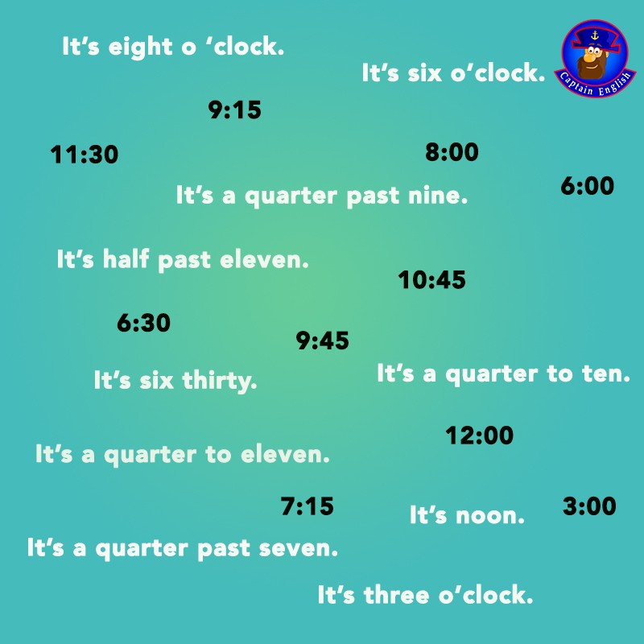



*104*

1. **– What time is it? Write what time it is under each clock:**

|  |  |  |
| --- | --- | --- |
|  |  |  |
|  |  |  |
|  |  |  |



*105*

SONG 17

# It’s My Life by Bon Jovi

**Learning Focus**: Possessive Adjectives and Possessive Pronouns. Reflexive and Emphasizing Pronouns.



**About Bon Jovi**

Bon Jovi is a famous American rock band. The members of the band have changed in the past few years, but nowadays the band is formed by Jon Bon Jovi, who is the lead singer, David Bryan, the pianist, Tico Torres, the drummer, Phill X, the guitarist and Hugh McDonald, the bassist. They have sold more than 130 million records and ‘It’s My Life’ is one of their great hits.



*106*

# Activities

## – Listen to the song and complete the lyrics:

This ain't a for the broken-hearted

No silent for the faith-departed

I ain't gonna be just a face in the crowd You're gonna hear my

When I shout it out loud

## – Put the sentences in the correct order:

( ) It's now or never ( ) Like Frankie said

( ) I just wanna live while I'm alive ( ) I ain't gonna live forever

( ) I just want to live while I'm alive ( ) It's my life

( ) (It's my life)

( ) My heart is like an open highway ( ) I did it my way

( ) It's my life

## – Complete:

This is for the ones who stood their For Tommy and Gina who never backed down Tomorrow's getting harder make no



*107*

Luck ain't even lucky

Got to make your own

## – Put the sentences in the correct order:

( ) It's now or never

( ) I just wanna live while I'm alive ( ) I just want to live while I'm alive ( ) (It's my life)

( ) 'Cause it's my life

( ) My heart is like an open highway ( ) It's my life

( ) Like Frankie said

( ) I ain't gonna live forever ( ) I did it my way

Better stand tall when they're calling you out Don't bend, don't break, baby, don't back down

( ) My heart is like an open highway ( ) Like Frankie said

( ) 'Cause I ain't gonna live forever ( ) I just wanna live while I'm alive ( ) I just wanna live while I'm alive ( ) (It's my life)

( ) It's my life

( ) I did it my way ( ) (It's my life)

( ) It's now or never

( ) 'Cause It's my life

( ) I ain't gonna live forever



*108*

( ) I did it my way

( ) I just wanna live while I'm alive ( ) (It's my life)

( ) My heart is like an open highway ( ) Like Frankie said

( ) It's now or never

( ) I just wanna live while I'm alive

## – Relate the opposites:

1. forever ( ) close
2. alive ( ) no
3. open ( ) strong
4. down ( ) dead
5. weak ( ) never
6. war ( ) old
7. win ( ) lose
8. yes ( ) peace
9. young ( ) up

## – Change the sentences into interrogative:

1. Gina backed down.
2. Frankie said that.
3. You are just a face in the crowd.



*109*

1. They shout it out loud.
2. We are going to hear his voice.

Do you know the Possessive Adjectives and Possessive Pronouns?

|  |  |
| --- | --- |
| POSSESSIVE ADJECTIVES | POSSESSIVE PRONOUNS |
|  |  |
| My | Mine |
| Your | Yours |
| His | His |
| Her | Hers |
| Its | ------ |
| Our | Ours |
| Your | Yours |
| Their | Theirs |

## – Now complete the sentences with Possessive Adjectives or Possessive Pronouns:

1. This is Peter’s bike, but that one is not .
2. “Is this your key?” “Yes, it’s .
3. My sister studies in a great school. classroom is very big.
4. This house belongs to me, so, it’s house.
5. John and Mary live next to me. This is my apartment and that one is

.

1. The cat is eating food.
2. “Is this Jennifer’s office?” “Yes, it is .



*110*

1. “Do those bikes belong to your brother and you?” “Yes, they are q .”

Do you know the Reflexive and Emphasizing Pronouns?

|  |
| --- |
| REFLEXIVE AND EMPHASIZING PRONOUNS |
| Myself |
| Yourself |
| Himself |
| Herself |
| Itself |
| Ourselves |
| Yourselves |
| Themselves |

## – Let’s complete the sentences with reflexive or emphasizing pronouns:

1. I want to see this.
2. Be careful with this knife or you will cut .
3. She made the cake .
4. He saw in the mirror.
5. Joana lives by in the apartment.
6. We answer the questions.
7. Boys, behave !
8. The players hurt in the baseball game.
9. The dog ate all meat.



*111*

SONG 18

# Wonderwall by Oasis

**Learning Focus**: Demonstrative Pronouns.

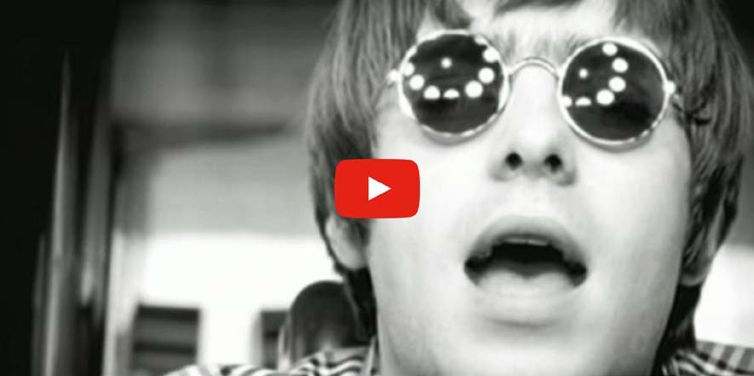

**About Oasis**

If it wasn’t a family matter, Oasis would be still playing nowadays. They were a great rock band and Wonderwall is one of their greatest song. Liam, the lead singer and Noel, the lead guitar player are brothers and after a fight, they decided to end Oasis. It’s a pity. They were a terrific band.



*112*

# Activities

## – Listen to the song and complete the lyrics:

Today is gonna be the day

That they're gonna throw it to you By now you should've somehow

Realized what you gotta do

I don't believe anybody Feels the way I do

About you

Backbeat the word is on the street

That the fire in your is out I'm sure you've heard it all before

But you never really had a doubt

I don't that anybody Feels the way I do

about you now

And all the roads we have to are winding And all the lights that lead us there are blinding

There are many that I'd Like to say to you

But I don't know how

Because maybe

You're gonna be the one that me And all



*113*

You're my wonderwall

Today was gonna be the day

But they'll never throw it back to you By now you should've somehow

what you're not to do I don't believe that anybody

the way I do About you now

And all the that lead you there were winding And all the that light the way are blinding There are many things that I'd like to say to you

But I don't know how

I said maybe

You're gonna be the one that me And all

You're my wonderwall

I said maybe (I said maybe)

You're gonna be the one that me And all

You're my wonderwall

I said maybe (I said maybe)

You're gonna be the one that saves me (that saves me)3x



*114*

## – Look for the name of the pictures below in the lyrics:



1. **- Now complete the sentences using the vocabulary from the activity 2.**
2. I guess John is in love. He was drawing a little in his notebook.
3. Be careful when you are crossing the .
4. You have to turn on the when he enters.

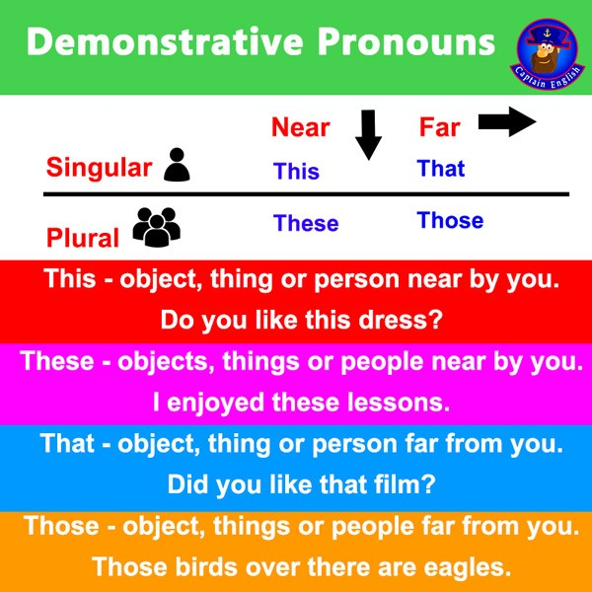

1. Did you like this / these shoes?
2. Look how cute this / these dog is!
3. This / These new app is perfect for me.
4. This / These oranges aren’t tasteful.
5. I can’t go right now. I have to read all this / these emails.
6. This / These children have been playing all day long.
7. I don’t understand this / these activity.
8. This / These woman is my aunt.
9. This / These women are my friends.

## – That or Those? Circle the correct alternative:

1. Mary lives in that / those house over there.
2. Who are that / those men?
3. I don’t know that / those people.
4. That / Those man is Rosa’s husband.
5. Please, clean up that / those papers for me.
6. Did you watch that / those movie?
7. I think that / those shirts are too expensive.
8. That / Those cars shouldn’t park over there.
9. Is that / those bus going downtown?



*116*

## – Complete with this, that, these or those.

1. Who are people over there?
2. Who is person over there?
3. I didn’t like dress.
4. Can you see man across the street?
5. is my sister Ellen.
6. I want to buy shoes. I loved them!
7. Do you remember people we met in France?



*117*

SONG 19

# Hello, Goodbye by The Beatles

 **Learning Focus**: Synonyms and Antonyms.

### Reading Comprehension.

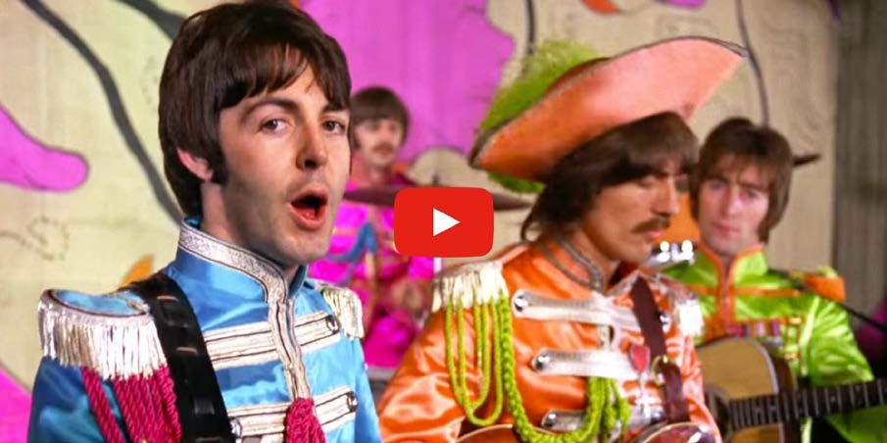

**About The Beatles**

The Beatles were an English rock band formed in Liverpool in 1960. With members John Lennon, Paul McCartney, George Harrison and Ringo Starr, they became very famous and the most influential act of the rock era. In 1963 their enormous popularity first emerged as "Beatlemania”.

The Beatles built their reputation playing in Liverpool and Hamburg over a three- year period from 1960. Their first hit was “Love Me Do”, in late 1962. They acquired the nickname "the Fab Four".



*118*

# Activities

## – Listen to the song and complete the lyrics:

You say yes, I say no.

You say and I say go go go, oh no. You say goodbye and I say hello

Hello hello

I don't know you say goodbye, I say hello Hello hello

I don't know why you say goodbye, I say hello.

I say , you say . You say why and I say I don't know, oh no.

You say goodbye and I say hello

(hello goodbye hello goodbye) hello hello

(hello goodbye) I don't know why you goodbye,

I say hello

(hello goodbye hello goodbye) hello hello

(hello goodbye) I don't know why you say goodbye (hello goodbye) I say hello

Why why why why why why do you Say goodbye goodbye, oh no?

You say goodbye and I say hello Hello hello

I don't why you say goodbye, I say hello Hello hello

I don't know why you say goodbye,



*119*

I say hello.

You say yes (I say "yes")

I say no (but I may mean no) You say stop (I can stay)

And I say go go go (till it's time to go )

You say goodbye and I say hello Hello hello

I don't know why you say goodbye, say hello Hello hello

I don't know why you say goodbye, I say hello Hello hello

I don't know why you say goodbye, I say hello hello. Hela heba helloa cha cha, hela...

## - Find the opposites in the lyrics:

Hello -

Yes -

Go -

Because -

Don’t -

High -



*120*

## - Now find the synonyms of the words below in the song:

Announce -

Hi -

Bye-bye -

Pause -

Affirmative -

## – Read again about The Beatles and answer the questions about it:

1. Where were The Beatles from?
2. What was their nickname?
3. What was their first hit?
4. How many members were in the band?

## – Write T for true sentences and F for false sentences according to the text:

1. ( ) There were six members in the band.
2. ( ) The Beatles were famous only in England.
3. ( ) ‘Love Me Do’ was their first hit.
4. ( ) The band was formed in Liverpool.
5. ( ) Their song style was hip hop.
6. ( ) They emerged as Beatlemania in 1963.



SONG 20

# Marry You by Bruno Mars

**Learning Focus**: Parts of the Body. Reading Comprehension. Abbreviations.



**Engagement Ring**

An engagement ring indicates that the person wearing it is engaged to be married. A ring is presented as an engagement gift by a partner to their prospective spouse while they propose marriage or directly after a marriage proposal is accepted. It represents a formal agreement to future marriage. In Western countries, it is customarily worn on the left hand ring finger, though customs vary across the world.



*123*

# Activities

## – Listen to the song and complete the lyrics:

It's a beautiful

We're looking for something to do Hey baby

I think I wanna marry you

Is it the look in your

Or is it this dancing juice? Who cares, baby

I think I wanna marry you

Well I know this little on the boulevard we can go No one will know

Oh come on girl

Who if we're trashed Got a pocket full of cash we can blow Shots of

And it's on girl

Don't say no, no, no, no-no

Just say yeah, yeah, yeah, yeah-yeah And we'll go, go, go, go-go

If you're ready, like I'm ready

Cause it's a beautiful night

We're looking for something dumb to do



*124*

Hey baby

I think I wanna marry you

Is it the look in your eyes Or is it this dancing juice? Who cares baby

I think I wanna marry you

I'll go get a let the choir bells sing like So what you wanna do?

Let's just girl

If we wake up and you wanna break up that's

No, I won't blame you It was fun girl

Don't say no, no, no, no-no

Just say yeah, yeah, yeah, yeah-yeah And we'll go, go, go, go-go

If you're ready, like I'm ready

Cause it's a beautiful night

We're looking for something dumb to do Hey baby

I think I wanna marry you

Is it the look in your eyes Or is it this dancing juice? Who cares baby

I think I wanna marry you Just say I do



*125*

Tell me right now baby

Tell me right now baby baby (x2)

## – Can you write the whole paragraph?

It’s a beautiful ...

Is it the look in your eyes Or is it this dancing juice? Who cares baby

I think I wanna marry you...

## – Bruno Mars uses some abbreviations in his song. In the English language, there are a lot of words people abbreviate. Here are some examples. Relate the words to their abbreviation.

) Going to

|  |  |
| --- | --- |
| a) Wanna | ( |
| b) Gonna | ( |
| c) Gotta | ( |
| d) Ain’t | ( |
| e) Dunno | ( |
| f) Cause | ( |

) Because

) Want to

) I don’t know

) Got to

) To be not



*126*

## – Read again the text about engagement ring and write T for true sentences and F for false sentences.

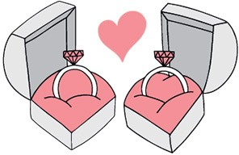

1. ( ) All women wear engagement ring.
2. ( ) A partner can give a ring as a present to their prospective spouse while they propose a marriage.
3. ( ) An engagement ring indicates that the person who is wearing is engaged.
4. ( ) In some countries it’s customarily wear the ring on the left hand.
5. ( ) It’s not an obligation to wear an engagement ring.



*127*

1. **– Write the name of the body parts:**

nose – leg – finger – eye – mouth – arm – hand – foot – belly - ear



*128*



SONG 21

**Suspicious Mind by Elvis Presley**

 **Learning Focus**: Modal Verbs. Simple Past.



**Suspicious Mind**

This is one of the most famous song by Elvis Presley. It talks about a jealous person that is always suspicious about their partner. There are people who say being a little bit jealous is good for the relationship. Do you agree? Are you a jealous person?



*129*

# Activities

## – Listen to the song and complete the lyrics:

We're caught in a trap I can't out

Because I love you too much baby

Why can't you see

What you're doing to me

When you don't a word I say?

We can't on together With suspicious minds

And we can't build our dreams On suspicious minds

So, if an old friend I

Drops by to hello

Would I still see suspicion in your eyes?

Here we go again Asking where I've been

You can't these tears are real I'm crying

We can't go on together With suspicious minds

And we can't our dreams On suspicious minds

Oh let our love Or dry the tears from your eyes Let's not let a good thing die

When honey, you know I've never lied to you

## – Put the sentences in the correct order:

( ) I can't walk out

( ) We're caught in a trap

( ) Because I love you too much baby

( ) When you don't believe a word I say? ( ) What you're doing to me

( ) Why can't you see

We're caught in a trap I can't walk out

Because I love you too much baby

## – All the verbs you had to use in this lyric were in the present tense. Change all them into simple past:



*131*



When Elvis Presley sings ‘Why can’t you see’, he is using a modal verb ‘can’t’. Let’s see other Modal Verbs:

|  |  |  |
| --- | --- | --- |
| **Modal Verbs** | **Use** | **Negative Form** |
|  |  |  |
| Can | permission/ability/possibility | Cannot/ Can’t |
| Could | ability/ permission | Could not/ Couldn’t |
| May | possibility/ permission | May not |
| Might | possibility (present and  past) | Might not/ Mightn’t |
| Must | obligation/ probability | Must not/ Mustn’t |
| Should | advice | Should not/ Shouldn’t |

## - Match the appropriate requests to the situations.

1. You need change for the bus. Ask your friend.
2. You need help with a problem. Ask your teacher.
3. You forgot to bring a pencil to class. Ask a classmate.



*132*

1. You want to know where the restroom is. Ask the waiter.
2. You need help fixing a flat tire. Ask a stranger.
3. You want the newspaper. Ask your friend.
4. You want some groceries from the shop. Ask your mother.
5. You need a day off. Ask your boss.

( ) Mom, can you bring some cereals for me? ( ) Hey, can I borrow a pencil?

( ) Excuse me, sir. I have to attend to a funeral tomorrow. Could I have the day off?

( ) Excuse me, sir. I have a flat tire. Could you help me fix it?

( ) Excuse me, ma’am. Can you help me? What is the meaning of “powerful”?

( ) Excuse me, could you tell me where the restroom is? ( ) Can you lend me some change for the bus?

( ) Can you buy me the newspaper?



*133*

## - Read the advices and write them under the correct picture:

* + You should start a diet.
  + You should study more.
  + You should wear a coat.
  + You should go to the dentist.
  + You should take some medicine.
  + You should go to bed earlier.

|  |  |  |
| --- | --- | --- |
| I have a stomachache. | I’m tired! | I got a bad grade. |
| You should… |  |  |
| I’m getting too fat. | I have a toothchache! | It’s cold today. |
|  |  |  |



*134*

## – Obligation and Prohibition. Copy the statements under the appropriate signs:

You mustn’t drink Women only

Men only You must not smoke

Recycle Men or Women

|  |  |  |
| --- | --- | --- |
|  |  |  |
| You must not smoke | Recycle | You mustn’t drink |
|  |  |  |
| Women only | Men or Women | Men only |

# Answers

**Song 1 – Sugar by Maroon 5**



*135*

1. **– Listen to the song and complete the lyrics**:

Hurting Loving Begging Needing Killing

1. **– Put the sentences in the correct order:**

2 – 6 – 8 – 3 – 4 – 1 – 5 – 10 – 7 – 8 – 9

1. **– Complete:**

Pieces Insecure Living Where

1. **– Put the sentences in the correct order:**

6 – 1 – 3 – 4 – 2 – 5 – 10 – 7 – 9 – 11 – 8

1. **– Complete:**

Red Touch Way Games

1. **– Match the sentences to the pictures:**

1.  2. 

3.  4. 

( 4 ) Red Velvet ( 1 ) On my knees ( 2 ) Afraid ( 3 ) Weak

1. **– What does SUGAR mean in this song? What picture is better related to the meaning in the song?**

 ( x )  ( )

1. **– There are many feelings in this song. Relate the feelings to their meanings:**
2. happy ( e ) fragile
3. sad ( b ) unhappy
4. angry ( g ) feeling fear
5. hungry ( a ) glad
6. weak ( d ) need for food
7. strong ( c ) showing anger
8. afraid ( f ) having muscular body
9. **– Write the -ing forms of these verbs. You can find these verbs in the lyric:**

Hanging Loving Killing Hurting Begging

1. **– Write Present Continuous affirmative (+) and negative (-) sentences:**
2. is enjoying
3. are listening
4. isn’t playing
5. isn’t raining
6. are going
7. am reading
8. isn’t talking
9. are drinking
10. is sleeping
11. am not working
12. **– Use PC for Present Continuous, SP for Simple Present and SPA for Simple Past sentences:**
13. PC f) SPA
14. PC g) SP
15. SPA h) SP
16. PC i) SPA
17. SPA j) SP

**Song 2: Halo by Beyoncé**

* 1. **– Listen to the song and complete the lyrics:**

Built Put

Found Had Got

Awakened Shut

Embrace Grace

Written Fade

Darkest Addicted Swore Forget

Surrounded

* 1. **– Relate the words with the correct meaning:**

C – A – E – B – D

* 1. **– Change the sentences into negative:**

1. You aren’t everything I need. (You are not)
2. You aren’t my saving grace. (You are not)
3. I’m not surrounded by your embrace. (I am not)
4. It isn’t written all over your face. (It’s not)
5. I’m not addicted to your light. (I am not)
   1. **– Complete the sentences with AM, IS or ARE:**
6. ARE
7. IS
8. ARE, AM
9. IS
10. ARE
11. ARE, AM
    1. **– Rewrite the following sentences using personal pronouns (I, you, he, she, it, we, they):**
12. She likes him very much.
13. He called her last night.
14. You danced the whole night together.
15. We are going to the movies.
16. She wants to buy a new car.
17. He does his homework at night.

**Song 3: Closer by The Chainsmokers**

1. **– Complete with the words you hear:**

Met Issue Meet See

Breaks Broke Looking

1. **– Now put the sentences in the correct order:**

6 – 2 – 4 – 3 – 5 – 7 – 1

1. **– Complete with the words you listen:**

Look Forget Beat

1. **– Put the sentences in the correct order:**

6 – 4 – 3 – 1 – 7 – 2 – 5 – 5

1. **– Complete:**

Backseat Know Shoulder Mattress Roommate

1. **– Change the sentences below into the past tense. Check the lyric for some help:**
2. You stole the mattress from your roommate.
3. I was insane.
4. I moved to another city.
5. They played that Blink-182 song.
6. I drank too much.
7. **– What are they doing?**
8. She’s drawing D) She’s singing
9. He’s reading E) He’s drinking
10. She’s eating F) She’s painting

( E )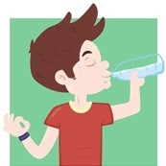 ( C )



*136*



*137*

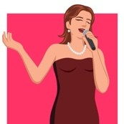( F ) ( D )

( A )  ( B ) 

1. **– Read the hints and complete the Crossword Puzzle with the verbs in the Present Continuous:**

ACROSS

4) doing

1. biting
2. seeing
3. closing

DOWN

1. playing
2. studying
3. speaking

5) listening

1. letting
2. stopping
3. **- Closer, older, there are some comparative words in this song. For short nouns, we just add -er. But for bigger nouns we need to use more, as more beautiful, more dangerous. Complete the sentences using the correct comparative:**
4. taller
5. older
6. longer
7. more handsome
8. more curious
9. more dangerous
10. smaller
11. more difficult
12. younger
13. more intelligent

**Song 4: Hello by Adele**

**1 – Listen to the song and complete the lyrics:**

Wondering Everything Healing

Dreaming Forgotten

Us A

From To Call

Say Tear

Myself Well Nothing

Secret

Thousand When

Outside Clearly

1. **– Rewrite the sentences using the adverb in parentheses.**
2. Do you ever have vacation?
3. When do you generally go to bed?
4. How often does he usually call you?
5. Do you sometimes travel during your vacation?
6. **– Where can you put the adverb in this sentence? Indicate the location with an “X”.**
7. I never ask questions in that professor’s class.
8. An impolite person always interrupts others while they are speaking.
9. Bad drivers rarely park their car correctly.
10. It is seldom cold in the spring in Miami.
11. **– There are some sentences where the adverb is in the correct place and in other sentences it isn’t. Correct the sentences that are wrong.**
12. it’s correct
13. John is always late.
14. John is always late.
15. it’s correct
16. He never does it well.
17. He never does it well.
18. it’s correct
19. I seldom work hard.
20. I seldom work hard.
21. **– Put the sentences in the correct order:**
22. Do you always buy clothes at the store?
23. I never eat Chinese food.
24. Have you ever gone to Paris?
25. They rarely go to the movies on weekends.
26. The kids sometimes play together.

**Song 5: Story of My Life by One Direction**

1. **– Listen to the song and complete the lyrics:**

Stories Days

Morning Stone

1. **– Circle the correct alternative:**

TONIGHT FEET TIGHT BETWEEN

1. **– Put the sentences in the correct order:**

2 – 1 – 4 – 6 – 5 – 3 – 7

1. **– Circle the correct alternative:**

WALLS CHANGE CAGE

NOW BROKEN

1. **– Put the words in the sentences in the correct order:**
2. **– Look for the name of these images in the song:**



BONE FEET



STONE WALL

1. **– Try to find the synonyms of these words in the song:**
2. chasing
3. holding
4. see
5. waiting
6. story
7. **– Relate the words to the correct climate:**



WARM WINDY



RAINY FROZEN

And I’ll be gone gone tonight

The fire beneath my feet is burning bright The way that I’ve been holding on so tight

With nothing in between



*138*

* 1. **– Put the sentences in the correct order:**

2 – 5 – 1 – 3 – 6 – 4 – 7

* 1. **– Complete:**

Time After Clouds

Night Life Inside

**Song 6: Love Yourself by Justin Bieber**

1. **– Listen and put the sentences in the correct order:**

3 – 2 – 4 – 1

1. **– Circle the correct word:**

WRITE STILL THINK SHOULD

1. **– Complete with the missing words:**



*139*

Everyone Admit Job Sleeping

1. **– Cross out the extra word:**

Don’t Girl Still Not

1. **– Put the sentences in the correct order:**

3 – 2 – 4 – 1

1. **– Circle the correct word:**

WRITE STILL THINK SHOULD

1. **– Complete with the missing words:**

Everyone Admit Job Sleep

1. **– All the sentences below are in the past tense. Can you change them into the present tense?**
2. Am I a fool to let you break down my walls?
3. For all the times that you make me feel small.
4. Because I don’t want anyone thinking I still care.
5. Try to make me foget where I come from.
6. When you tell me that you hate my friends.
7. **– Relate the words to their meaning:**

D – E – A – B – C

1. **– To ask questions in the simple past, you have to use the auxiliary verb DID. Don’t forget when you ask a question in the past tense, the spelling of the verb is in the infinitive form, without ‘to’:**
2. Did you try to make me forget where I came from?
3. Did you make me feel small?
4. Did you tell me that you hated my friends?
5. Did you break my heart?
6. **- Now let’s change these same sentences into the negative form. In the simple past tense, use the auxiliary verb ‘didn’t’ to change a sentence into negative. The main**

**verb is also spelling in the infinitive form, without ‘to’.**

1. You didn’t try to make forget where I came from.
2. You didn’t make me feel small.
3. You didn’t tell me that you hated my friends.
4. You didn’t break my heart.

**Song 7: Perfect Illusion by Lady Gaga**

1. **– Complete with the words you listen:**

Control Middle Strong Wrong Know

1. **– Cross the extra word out:**

My Just One Just Only

1. **– Put the sentences in the right order:**

4 – 2 – 7 – 3 – 8 – 1 – 5 – 6

1. **– Complete with the vowels:**

It wasn’t love, it wasn’t love

It was a perfect illusion (perfect illusion) Mistaken for love, it wasn’t love

It was a perfect illusion (perfect illusion)

1. **– Put the letters in order:**

OVER LEAST

1. **– Complete the sentences with WAS or WERE:**
2. was
3. were
4. were
5. were
6. were
7. was
8. was
9. were
10. were
11. was, was
12. were
13. **- There are two forms of the verb to be in the past: was and were. When you have a sentence with was or were, you don’t use DID as an auxiliary verb to ask questions. You have to use was or were. Just put it in front of the pronoun. Let’s try! Change the sentences below into interrogative:**



*140*

1. It wasn’t a perfect illusion.
2. You weren’t so perfect.
3. It was not love.
4. You were not a perfect illusion.

**Song 8: Photograph by Ed Sheeran**

1. **– Circle the right word:**

LOVING KNOWING GET THING

LOVE THESE CLOSING BROKEN STILL

1. **– Complete with the words you listen:**

Keep Ripped Close Come

Heal Easier Piece

Love These Closing

Keep Ripped Close

1. **– Put the sentences in the right order:**

8 – 3 – 7 – 4 – 5 – 1 – 6 – 2

1. **– Now check out these sentences from the song. Are they in the Present (P), Past (PA) or Future (F) Tense? Read and decide.**
2. P
3. P
4. F
5. PA
6. F
7. P
8. **– Complete the sentences using WHEN, WHERE, WHAT, WHO or WHOSE:**
9. where
10. where
11. whose
12. where / when
13. what
14. who
15. when
16. whose
17. who
18. what
19. **- Have you listened to a song by Ed Sheeran before? What do you know about him? Read the text and answer the questions below.**

a) He was born in February 17th, 1991 in Halifax, West Yorkshire.

b) In 2012.

c) Contemporary Music in Guilford.

1. **– Now complete with the prepositions IN or ON:**
2. on
3. in
4. in
5. in
6. in
7. in
8. on
9. on

**Song 9: The Scientist by Coldplay**

1. **– Listen to the song and complete the lyrics:**

Meet Need Set Start

1. **– Organize the words in sentences:**

Nobody said it was easy

It’s such a shame for us to part Nobody said it was easy

No one ever said it would be this hard Oh take me back to the start

1. **– Listen and complete:**



*141*

Numbers Puzzles Come Circles

1. **– Circle the correct option:**

EASY PART SAID HARD START

1. **– Check the other ways to say “I’m sorry”.**

It’s my fault.

I’m terribly sorry. Please, forgive me.

Please, accept my apologies.

1. **– Check the other ways to say “How are you?”.**

What’s up?

How are you keeping? How is it going?

How have you been?

1. **– Look up the name of these pictures in the lyrics:**



1. Circles 2. Puzzles

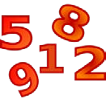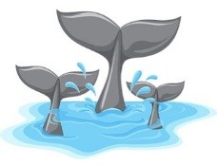

3. Numbers 4. Tails

1. **– Complete with SOMEBODY, NOBODY or ANYBODY:**
2. nobody
3. anybody
4. nobody
5. somebody
6. anybody
7. somebody
8. anybody
9. anybody
10. anybody
11. nobody
12. **– Fill in the blanks. Use SOME, ANY or NO:**
13. any
14. some
15. any
16. some
17. any
18. any
19. some
20. any
21. any
22. no

**Song 10: Love Story by Taylor Swift**

1. **– Listen to the song and complete with the words from the box.**

Both Flashback Lights Crowd

Away Staircase

Alone Left

Garden Town

Save Tired Ring Marry

1. **– Question:**

It’s a tragedy story written by William Shakespeare about two lovers whose families were enemies.

1. **– Relate the masculine to the feminine nouns:**

F – K – I – A – J – B – G – C – D – E – H

1. **– Try to explain the meaning of:**

Stay Away: Not be near or involved with someone or something.

Begging: Ask for something.

Flashback: A short part of a story that goes back to events in the past.

1. yet
2. yet
3. already
4. **– Complete with the Present Perfect:**
5. have – been



*142*

1. haven’t gone
2. has driven
3. has finished
4. has read
5. have – drunk
6. has – slept
7. has – done
8. has worked
9. **– Complete the table using the Present Perfect:**

|  |  |  |
| --- | --- | --- |
| **AFFIRMATIVE** | **NEGATIVE** | **INTERROGATIVE** |
| He has written a letter. | He has not written a letter. | Has he written a letter? |
| They have stopped. | They have not stopped. | Have they stopped? |
| We have danced. | We haven’t danced. | Have we danced? |
| She has worked. | She hasn’t worked. | Has she worked? |
| Andy has slept. | Andy has not slept. | Has Andy slept? |

1. **– Complete with FOR, SINCE or AGO:**
2. for
3. since
4. for
5. ago
6. for
7. since
8. ago
9. since
10. for
11. since
12. **– Complete with ALREADY or YET:**
13. yet
14. already
15. yet
16. already
17. already
18. yet
19. already

**Song 11: Don’t Speak by No doubt**

1. **– Complete the words just using vowels:**

You and me

We used to be together, Every day together always

1. **– Write the full sentences:**

I really feel

I can’t believe

1. **– Complete with the missing words:**

Letting Real Know

1. **– Put the chorus in the correct order:**

8 – 2 – 6 – 7 – 3 – 1 – 4 – 5

1. **– Complete:**

Memories Altogether

Hands

1. **– Put the chorus in the correct order:**

3 – 4 – 1 – 6 – 7 – 5 – 8 – 2

1. **– Put the chorus in the correct order:**

4 – 8 – 6 – 3 – 1 – 2 – 5 – 7

1. **– Complete the Crossword Puzzle with the words from the song:**

Down

1. together
2. die

4. memories

6. stop

Across

3. losing

1. believe
2. speak
3. always
4. **– Take a look at these tips for a good health, then write the sentences under the correct picture:**

Out Face



*143*

|  |  |  |  |
| --- | --- | --- | --- |
|  |  |  |  |
| E | G | D | C |
|  |  |  |  |
| A | B | F | H |

Spoons Wife

1. **– Complete with the imperative of the verbs in parentheses:**
2. Open
3. Don’t drink
4. Eat
5. Don’t talk
6. Close
7. Don’t eat
8. **– Read the sentences and correct the wrong ones:**
9. Don’t play football in the yard.
10. The sentence is correct.
11. Don’t talk during class.
12. The sentence is correct.
13. Go to your room right now.

**Song 12: Ironic by Alanis Morissette**

1. **– Complete with the verbs in the past:**

Turned Died Won

1. **– Relate the sentences:**

C – A – D – B

1. **– Complete with the verbs in the Past Tense:**

Was Packed Waited Crashed

1. **– Write the sentences in the correct order:**

It’s like rain on your wedding day

It’s a free ride when you’ve already paid It’s the good advice that you just didn’t take Who would’ve thought it figures

1. **– Listen and complete:**

Funny Think

1. **– Now try to write the whole paragraph:**
2. It’s like rain on your wedding day
3. It’s a free ride when you’ve already paid
4. It’s the good advice that you just didn’t take
5. Who would’ve thought it figures
6. **– Relate the verbs to the pictures:**

|  |  |
| --- | --- |
|  | WIN |
|  | WAIT |
|  | CRASH |
|  | PACK |
|  | DIE |

1. **– Complete the sentences using the verbs from activity 7:**
2. Die
3. Crash
4. Pack
5. Wait
6. Win
7. **– Fill in the brackets with the verbs below in the correct form of the Simple Present:**

Wakes up Takes Brushes Goes

Has Walks Waits Writes Discusses Checks Talks Leaves Watches Goes out

1. **– Complete the sentences with one of the options:**

a)

do



*144*

do, does

b) is is

c) don’t is

is

d) do are do

e) isn’t is

is do

don’t

**Song 13: Black or White by Michael Jackson**

* 1. **– Listen to the song and complete:**

Saturday Girl Tonight

Message Equality

* 1. **– Put the sentences in the correct order:**

2 – 7 – 3 – 8 – 4 – 1 – 6 – 5

2 – 4 – 5 – 9 – 1 – 6 – 7 – 3 – 8 – 10

* 1. **– Complete:**

Eye Brother

* 1. **– Put the days of the week in the correct order:**

Sunday – Monday – Tuesday – Wednesday – Thursday – Friday – Saturday

* 1. **– Put the months of the year in the correct order:**

January – February – March – April – May – June – July – August – September – October – November – December

* 1. **– Choose the words for each emojis below:**



1. Hungry 2. Angry 3. Scared



4. Tired 5. Happy 6. Sad

* 1. **– Now relate the antonyms:**

E – A – D – B – C

* 1. **– Mixing Colors. Do you know the color results when you mix these colors?**

RED + YELLOW = ORANGE RED + BLUE = PURPLE BLUE + YELLOW = GREEN BLACK + WHITE = GRAY RED + WHITE = PINK

**Song 14: Friday I’m in Love by The Cure**

1. **– Listen to the song and complete the lyrics:**

Blue Gray Care

Heart Start

Comes

Black Back

Head Instead

Comes



*145*

* 1. **– Now number the sentences in the correct order:**

5 – 2 – 3 – 6 – 7 – 1 – 8 – 13 – 9 – 4 – 11 – 12

– 14 – 10

* 1. **– Complete:**

Blue Gray

Heart Start

1. **– Now choose T (true) for true sentences and F (false) for false sentences according to the text:**

T – F – F – F – T – T

1. **– Replace the underline words for color idioms:**
2. True colors
3. In the dark
4. Blacked out
5. The green light
6. **– Besides saying “it’s Friday, I’m in love”, this song shows the days of the week. Can you write them in the correct order? Don’t forget that the days of the week always start with capital letters.**

Sunday, Monday, Tuesday, Wednesday, Thursday, Friday, Saturday

**Song 15: With or Without You by U2**

**1) Listen to the song and complete the lyrics:**

Stone Thorn Wait

Hand Bed Wait

Storm Give Waiting

Tied Got Win

Lose

1. **– Choose T for true and F for false sentences:**

F – T – T – F – T - F

1. **– Circle the words related to the weather:**

Storm, sun, wind, rain.

1. **– Circle the words related to the body parts.**

Arm, eyes, hands.

1. **– Relate the antonyms:**

B – C – A – D

1. **– Complete with the right article A or AN:**

A good artist AN hour

AN architect A house

AN umbrella AN honest man A woman

A green apple AN apple

A story

AN elevator AN airplane A bike

1. **– Complete the sentences using A or AN:**
2. a
3. an, a
4. an
5. a
6. an
7. an
8. an, a
9. an

**Song 16: Thousand Years by Cristina Perri**

**1 – Listen and complete the lyric:**

Fast Promises Love Alone

Afraid Thousand Breath

**7 – Draw a line to match the times:**

1. **– Put the sentences in the correct order:**

2 – 1 – 4 – 3 – 6 – 8 – 7 – 5

1. **– Circle the correct alternative:**

FOR LOVED YEARS MORE

FIND ME HAVE A

1. **– Find in the song lyrics:**
2. fast
3. closer
4. suddenly
5. brave
6. **– Change the sentences from the lyric into negative and interrogative form:**

a)

Negative: I haven’t died every day waiting for you.

Interrogative: Have I died every day waiting for you. Or Have you died every day waiting for me?

It’s eight o’clock – 8:00 It’s six o’clock – 6:00

It’s a quarter past nine – 9:15 It’s half past eleven – 11:30 It’s six thirty – 6:30

It’s a quarter to ten – 9:45

It’s a quarter to eleven – 10:45 It’s noon – 12:00

It’s three o’clock – 3:00

It’s a quarter past seven – 7:15

**8 – What time is it? Write what time it is under each clock:**

b)

|  |  |  |
| --- | --- | --- |
| It’s twelve thirty. It’s half past  twelve / noon. | It’s two thirty.  It’s half past two. | It’s seven o’clock. |
| It’s eleven thirty. It’s half past eleven. | It’s seven thirty. It’s half past six. | It’s eight fifteen.  It’s a quarter  past eight. |
| It’s three fifteen. It’s a quarter past three. | It’s four thirty. It’s half past four. | It’s five forty- five.  It’s a quarter to  six. |

Negative: I’m not afraid to fall.

Interrogative: Am I afraid to fall. Or Are you

afraid to fall?

c)



*146*

Negative: I haven’t loved you for a thousand years.

Interrogative: Have I loved you for a thousand years? Or Have you loved me for a thousand years.

d)

Negative: I won’t be brave.

Interrogative: Will I be brave. Or Will you be brave?

e)

Negative: Time has not brought your heart to me.

Interrogative: Has time brought your heart to me?

**6 – Relate the numbers to their writing:**

J – D – F – I – C – H – B – A – E - G

**Song 17: It’s My Life by Bon Jovi**

1. **– Listen to the song and complete the lyrics:**

Song Prayer Voice

1. **– Put the sentences in the correct order:**

2 – 7 – 4 – 3 – 9 – 1 – 5 – 6 – 8 – 10

1. **– Complete:**

Ground Mistake Breaks

1. **– Put the sentences in the correct order:**

2 – 4 – 9 – 5 – 10 – 6 – 1 – 7 – 3 – 8

6 – 7 – 3 – 4 – 9 – 5 – 1 – 8 – 10 – 2



*147*

9 – 2 – 7 – 3 – 4 – 5 – 6 – 1 – 8

1. **– Relate the opposites:**

C – H – E – B – A – I – G – F – D

1. **– Change the sentences into interrogative:**
2. Did Gina back down?
3. Did Frank say that?
4. Are you just a face in the crowd?
5. Did they shout it out loud?
6. Are we going to hear his voice?
7. **– Now complete the sentences with Possessive Adjectives or Possessives Pronouns:**
8. his
9. mine
10. its
11. my
12. theirs
13. its
14. hers
15. ours
16. **– Let’s complete the sentences with reflexive or emphasizing pronouns:**
17. myself
18. yourself
19. herself
20. himself
21. herself
22. ourselves
23. yourselves
24. themselves
25. itself

**Song 18: Wonderwall by Oasis**

**1 – Listen to the song and complete the lyrics:**

Back That Now

Heart Believe

Walk Things

Saves After

Realized Feels

Roads Lights

Saves After

Saves After

1. **– Look for the name of the pictures below in the lyrics:**



Road Lights Heart

1. **– Now complete the sentences using the vocabulary from the activity 2:**
2. heart
3. road
4. lights
5. **– This or These? Circle the correct alternative:**
6. these
7. this
8. this
9. these
10. these
11. these
12. this
13. this
14. these
15. **– That or Those? Circle the correct alternative?**
16. that
17. those
18. those
19. that
20. those
21. that
22. those
23. those
24. that
25. **– Complete with this, that, these, or those**.
26. those
27. that
28. this
29. that
30. this



*148*

1. these
2. those

**Song 19: Hello, Goodbye by The Beatles**

1. **– Listen to the song and complete the lyrics:**

Stop Why

Hi, low Say

Know I

1. **– Find the opposites in the lyrics:**

Goodbye No

Stop Why Do Low

1. **– Now find the synonyms of the words below in the song:**

Say Hello Goodbye Stop

Yes

1. **– Now answer the questions:**
2. They were from Liverpool.
3. The Fab Four.
4. Love me do.
5. Four.
6. **– Write T for true sentences and F for false sentences according to the text:**
7. F
8. F
9. T
10. T
11. F
12. F

**Song 20: Marry You by Bruno Mars**

1. **– Listen to the song and complete the lyrics:**

Night Dumb

Eyes

Chapel Cares Patron

Ring Run Cool

1. **– Can you write the whole paragraph?**

It’s a beautiful night

We’re looking for something dumb to to Hey baby

I think I wanna marry you

1. **– Bruno Mars uses some abbreviations in his song. In the English language, there are a lot of words people abbreviate. Here are some examples. Relate the words to their abbreviation.**

B – F - A – E – C – D

1. **– Write T for true sentences and F for false sentences.**
2. F
3. T
4. F
5. T
6. T
7. **– Write the name of the body parts:**

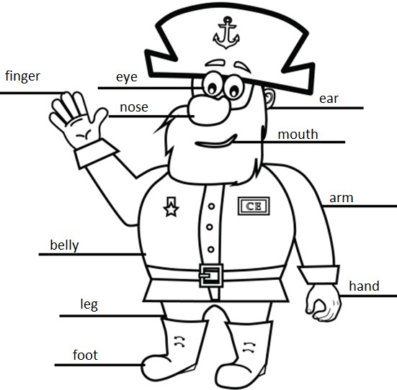

**Song 21: Suspicious Mind by Elvis Presley**

* 1. **– Listen to the song and complete the lyrics:**

Work Believe Go

Know Say

See

Build Survive

* 1. **– Put the sentences in the correct order:**

2 – 1 – 3 – 6 – 5 – 4

* 1. **– All the verbs you had to use in this lyric were in the present tense. Change all them into simple past:**

1. worked
2. believed
3. went
4. knew
5. said
6. saw
7. built
8. survived
   1. **– Match the appropriate requests to the situations.**

G – C – H – E – B – D – A – F

* 1. **– Read the advices and write them under the correct picture:**
  2. **– Obligation and Prohibition. Copy the statements under the appropriate signs:**

|  |  |  |
| --- | --- | --- |
|  |  |  |
| You must  not smoke | Recycle | You mustn’t  drink |
|  |  |  |
| Women  only | Men or  Women | Men only |



*149*

|  |  |  |
| --- | --- | --- |
| I have a stomachache. | I’m tired! | I got a bad grade. |
| *You should take some medicine* | *You should go to bed earlier* | *You should study more* |
| I’m getting too fat. | I have a toothchache! | It’s cold today. |
| *You should start a diet* | *You should go to the dentist* | *You should wear a coat* |



*150*

# Learn More

**Captain English Songs**

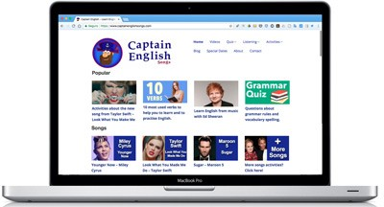Captain English Song is an Educational Company specializing in teaching English worldwide, promoting a wider knowledge about language and culture.

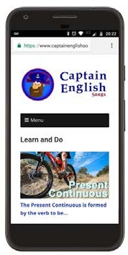On the website, you will find grammar explanations, listening activities, songs, special dates celebration, activities, crafts, coloring pages, quizzes and more.

You can also read articles that will help you to expand your English studies and teach you better ways to practice the language.

[**www.captainenglishsongs.com**](http://www.captainenglishsongs.com/)

**Follow Us**

#### [www.facebook.com/captainenglishsongs](http://www.facebook.com/captainenglishsongs) [www.instagram.com/captainenglishsongs](http://www.instagram.com/captainenglishsongs)

Follow Captain English Songs on Facebook and Instagram to be challenged with quizzes, learn grammar points, read about English culture and improve your skills.

#### [www.youtube.com/captainenglishsongs](http://www.youtube.com/captainenglishsongs)

Go to our YouTube Channel to check our videos with songs, nursery rhymes, chants and listening activities for kids. They love Captain English!

Bye, bye sailors!